A Level Super Curriculum
Further reading and resources

2025

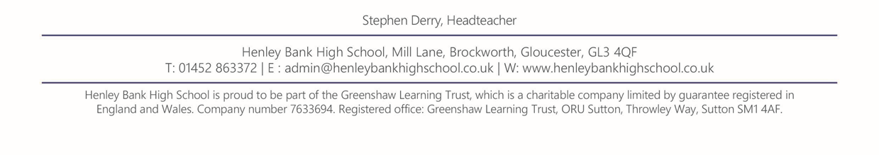

Please find below a range of websites that are available to support a range of subjects and interests:

Seneca learning: ( a free learning tool for both GCSE and A Level)
https://www.senecalearning.com/

Brighton College: ( a range of free resources for numerous subject areas)
https://www.brightoncollege.org.uk/college/enrichment/onlinelearning/

The next 20-30 pages includes subject specific further reading, resources and challenge from teachers:

Applying for Art –
Before choosing an undergraduate degree course check to see if a pre-degree course is necessary first. Sometimes referred to as Further Education (FE) courses; they give the opportunity to explore a wide range of subject areas before choosing a specialism for undergraduate-level study.
Most Arts based courses will require the submission of a Portfolio of work. Practical subjects such as architecture, art and photography will require images worked on to be included, while film programmes will require digital files of work. Similarly, more theory based topics will need evidence of writing ability.
The portfolio, should showcase creativity, imagination and technical ability relevant to the area of chosen study. It should consist of high quality images or pieces of work, including sketches and drafts to show how ideas have developed to demonstrate artistic skills and style. Most universities want to see hard copies of work, but may also expect the submitting of the portfolio as a digital file.
Preparations in addition to A Level Art work will need to be undertaken to demonstrate the key skills they will be looking for. Some key skills for Art & Design courses (depending on the area of specialism – i.e. Fashion/Fine Art/Graphics etc.) may include
- Imagination, creativity and ingenuity
- Critical awareness
- Interpersonal and social skills
- An appreciation for diversity
- Creative problem-solving and decision-making
- IT including using creative software
Some Courses will interview candidates, typical questions are –
- Why do you want to do this course?
- Did you attend the open day?
- Why do you want to study here?
- Do you have a favourite artist?
- What are your favourite books/magazines/films?
- What contemporary practitioner or artist inspires you?
- What are your most successful pieces of work?
- What exhibitions have you visited recently?
- Have you any ambitions of what you want to do in the future?

•What extra-curricular preparation have you done? – Exhibitions visited, addition courses/art clubs/drawing circles taken part in. Addition sketchbooks and journals compiled in addition to school based work. Which express motivation and enthusiasm, as well as a self-developed artistic education.

Magazines and Journals
New Scientist (www.newscientist.com)
Nature (www.nature.com)
Biological Sciences Review (https://www.liverpool.ac.uk/life-sciences/outreach/biological-sciences-review/)
Big Picture https://bigpictureeducation.com/
British Medical Journal (http://www.bmj.com)
Scientific American (https://www.scientificamerican.com/)
Books
Blood Work: A Tale of Medicine and Murder in the Scientific Revolution, Holly Tucker
Life Ascending, Nick Lane.
Genome, Matt Ridley.
The Energy of Life, Guy Brown
Bad Science, Ben Goldacre
The Human Brain: A Guided Tour, Susan Greenfield
The Immortal Life of Henrietta Lacks, Rebecca Skloot.
The Epigenetics Revolution, Nessa Carey
The Incredible Unlikeliness of Being, Alice Roberts
Calculus Diaries, Jennifer Ouellette.
Seed to Seed, Nicholas Harberd
The Botany of Desire, Michael Pollan
The Selfish Gene, Richard Dawkins
The Unnatural Nature of Science, Lewis Wolpert
Websites
www.intobiology.org.uk – A website that gives information on the latest research into Biology
www.aobblog.com – Short summary blog of up-to-date research on plant biology and ecology
https://www.ted.com/topics/biology - Educational lectures around many different subject areas
https://www.rsm.ac.uk/ and https://www.rsb.org.uk/ - Royal society for medicine and biology
http://www.accessexcellence.org/RC/VL/GG/ - Animations on latest development in biotechnology
https://www.bma.org.uk/ - Latest news in the world of medical sciences
https://www.bva.co.uk/ - Latest news in the world of veterinary sciences
Miscellaneous
Cambridge Science Podcasts: www.thenakedscientists.com/HTML/podcasts/
Oxford Science Podcasts: http://podcasts.ox.ac.uk/units/mathematical-physical-life-sciences-division
Radio programmes on Medical Ethics: https://www.bbc.co.uk/programmes/b007xbtd
Radio 4 Science and Nature Podcasts: https://www.bbc.co.uk/radio/categories/factual-scienceandnature
Online courses to help develop your subject knowledge and stand out from the crowd –
https://www.futurelearn.com/partners/university-of-leeds
or http://www.open.edu/openlearn/science-maths-technology/science/biology



Useful Websites & Podcasts:

The Royal Society of Chemistry (RSC) has an excellent website http://www.rsc.org/ which will be a useful source of information
Example: Podcasts on different elements Periodic Table: Podcast
‘Chemistry World’ - An interesting, accessible & topical publication – you are bound to find something here that interests you & will be useful for extending your knowledge, UCAS applications & interviews Chemistry World

‘Periodic videos’ is a YouTube channel hosted by Sir Martyn Poliakoff that has a video for every element on the periodic table and also demonstrates a lot of exothermic reactions. Periodic Videos - YouTube
Reading:
There are many good science-based books available to read for fun in popular fiction such as:
- What if?, Randall Munroe
- A is for Arsenic, the poisons of Agatha Christie, Kathryn Harkup
- The Knowledge: How to rebuild our world after an apocalypse, Lewis Dartnell
- Stuff Matters, Mark Midoiwnik

Wider reading : For more specific reading and UCAS applications, there are also many good books available, search online or in a bookshop. Choose one (or two) & ensure that you can describe how they interested you. There are too many to list but a selection are:

- Why chemical reactions happen – James Keeler & Peter Wothers
- The periodic kingdom, a journey into the land of chemical elements – P.W.Atkins
- Four Laws that drive the Universe - P.W.Atkins
- Nature’s Building blocks – J. Emsley
- Molecules at an exhibition – J. Emsley
- Magic molecules – how drugs work – Susan Aldridge
- Chemistry, an introduction to Organic, Inorganic and Physical Chemistry – Prof Catherine Housecroft

If you do not currently, or intend to, study maths at A-level, you may wish to have a book to help you:
- Maths for Chemists - Martin Cockett and Graham Doggett

Journals: The RSC has free access to many journals (see below) but it also has its own journal which focuses on reviewing new and emerging topics of chemistry, and brings together all the research on that topic which makes interesting reading Chemical Society Reviews
For more specific research & interesting articles, access the free journals RSC Free journals
There are over 30 available – look at ones that are specific to your interests/the course you are applying for. Some examples are below with links:
- Analyst1876 - Present
- Analytical Methods2009 - Present
- Biomaterials Science2013 - Present
- Catalysis Science & Technology2011 - Present
- Chemical Science2010 - Present
- Environmental Science: Nano2014 - Present
- Faraday Discussions1991 - Present
- Green Chemistry1999 - Present
- Inorganic Chemistry Frontiers2014 - Present

Chemistry specific, commonly used textbooks at Universities (not necessarily the easiest to read but will give you a flavour of the content)
*Some Universities will ask you to purchase/read certain chapters of these books before commencing the course, so maybe worth looking at pre-course reading lists.

- Physical Chemistry, P W Atkins, Oxford University Press
- Inorganic Chemistry, Shriver and Atkins, Oxford University Press
- Foundations of Organic Chemistry, Hornby & Peach, Oxford Chemistry Primer
- A Guide to Mechanism in Organic Chemistry, Sykes, Pearson
- Organic Chemistry, Maitland, Jones, Norton
- Mathematical Methods for Science Students, G. Stephenson, Pearson
- Organic Chemistry, Clayden, Greeves, Warren and Wothers, OUP
For UCAS applications : Some useful websites to access before interviews to ensure you are confident
Pre-University Chemistry Course
http://burton.chem.ox.ac.uk/how-to-use-curly-arrows.pdf

Summer Schools are offered by many universities – search on the internet & ensure you apply early as they are often over-subscribed. A local example is University of Bristol - Sutton Trust

ECONOMICS
Take part in Economics competitions. They are regularly published in the Financial Times for Schools. Institute of Economic Affairs and Bank of England’s websites:
https://www.ft.com/stream/dc4eb395-7eaa-4cea-a0c8-4ad46ec26347
https://www.bankofengland.co.uk/education/competitions
https://iea.org.uk/essay-competition/
Check out competitions, articles and suggested and texts at CoreEcon – Economics for sustainability. https://www.core-econ.org/
Do some really ambitious reading, find interest articles onProject Syndicate: http://www.project-syndicate.org/
Find some authors of new books on topics of particular interest and which challenge what you have been studying in routine lessons. For example: The Big Three in Economics: Adam Smith, Karl Marx, and John Maynard Keynes Hardcover – 15 Jan 2007 by Mark Skousen
Keep reading:
1. Animal Spirits (Akerlof and Shiller) ISBN: 978-0-691-14233-3
2. Art of Strategy (Dixit and Nalebuff) ISBN: 978-0-393-06243-4
3. Development as Freedom: (Amartya Sen): ISBN: 0192893300
4. Drunkard’s Walk (Leonard Mlodinow) ISBN: 0713999225
5. Economics – Short Introduction: (Partha Dasgupta): ISBN: 0192853457
6. How Markets Fail: The Logic of Economic Calamities (John Cassidy) ISBN: 1846143004
7. How we Decide: (Jonah Lehrer) ISBN 978-0-618-62011-1
8. Keynes – the Return of the Master (Skidelsky) ISBN: 184614258X
9. Logic of Life (Tim Harford): ISBN: 0316027561
10. Meltdown – the end of the age of greed (Paul Mason) ISBN: 1844673960
11. New Ideas from Dead Economists (Todd Buchholz) ISBN: 0452288444
12. Origins of Virtue (Matt Ridley) ISBN: 0140244042
13. Predictably Irrational: Hidden Forces That Shape Our Decisions (Dan Ariely) ISBN: 0007256523
14. Prophet of Innovation: Joseph Schumpeter and Creative Destruction (TK McCraw) ISBN: 0674025237
15. Return of Depression Economics and the Crisis of 2008 (Krugman) ISBN: 1846142393
16. The Ascent of Money (Niall Ferguson) ISBN: 014103548X
17. The Big Questions: Tackling the Problems of Philosophy with Ideas from Mathematics, Economics and Physics (Stephen Landsburg) ISBN: 143914821X
18. The Bottom Billion: Why the Poorest Countries Are Failing (Paul Collier): ISBN: 0195374630
19. Why Popcorn Costs So Much at the Movies: Other Pricing Puzzles (McKenzie) ISBN: 0387769994
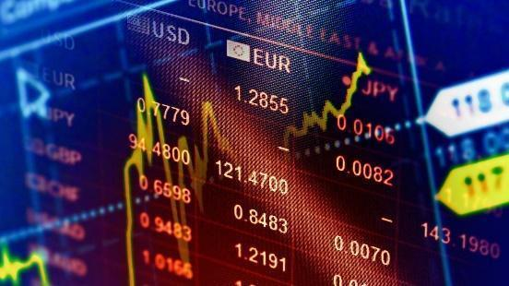

Watch films about Economics to develop your evaluative skills and ability to transfer theory into practice. https://inomics.com/insight/10-movies-all-economists-will-love-1292886

English Literature

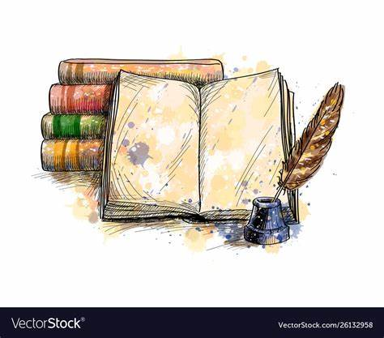
Studying English Literature opens on to the world of creative imagination. Not only does it develop skills that are essential for today’s global environment, but it also inspires change and innovation! English Literature studies help us understand our world in all its social, political, economic and cultural aspects through stories, novels, poems, and plays. How do you know if something you read is literature? Who decides whether a work is allowed to enter “the canon” and become required reading for students?

What to Watch:
Any theatre production
Film versions of classic texts e.g. the 1995 BBC Pride and Prejudice (otherwise known as THE BEST, EVER!)
Documentaries such as Shakespeare: Rise of a Genius, or Lucy Worsley’s series on Doyle or Christie (all BBC)

Have a Listen:
BBC Radio 4: Open Book, Woman's Hour, This Cultural Life
Book Riot: The Podcast, a weekly show that covers news and trends in the book world
Borrowed, a biweekly podcast that features stories and interviews from the Brooklyn Public Library
Debutiful, a monthly podcast that showcases debut authors and their books
Overdue, a podcast that reviews books that you've been meaning to read
Well-Read Black Girl, a podcast that celebrates the uniqueness of Black literature and sisterhood

Reading Recommendations

Dystopian Fiction: 1984, Fahrenheit 451, A Clockwork Orange, Brave New World, Never Let Me Go
American Literature: The Color Purple, Moby Dick, The Great Gatsby, The Sun Also Rises, The Catcher in the Rye
Feminist Texts: A Room of One’s Own, The Tenant of Wildfell Hall, The Yellow Wallpaper, The Scarlet Letter
Gothic Fiction: Dracula, The Picture of Dorian Gray, Rebecca, The Mysteries of the Udolfo, The Monk
Twisted Tales: Edgar Allan Poe Short Stories, The Bloody Chamber, Different Seasons (King), Grimm’s Fairy Tales
The Classics: Jane Eyre, Emma, Tess of the d'Urbervilles, Nicholas Nickleby, Wuthering Heights, Middlemarch
Something Lighter? Anything by P. G. Wodehouse, The Pursuit of Love, Pride and Prejudice
Play Texts: The Importance of Being Earnest, A Doll’s House, The Crucible, Cat on a Hot Tin Roof, Abigail’s Party
Criticism: The Concise Oxford Companion to English Literature, Shakespeare: The Invention Of The Human

Articles and competitions: EMC Magazines | English & Media Centre (englishandmedia.co.uk)

GEOGRAPHY
The study of Geography involves knowledge and understanding of a wide range of different topics. Therefore, many of the suggestions below are starting points which should help you identify your particular areas of interest. A rounded, well-prepared application will have a broad knowledge of current geographical issues whilst having explored some areas in greater depth. The ability of analyse and interpret geographical data (graphs, maps, tables GIS) is also a vital skill and is likely to be tested in interview.
READ
http://everythingisconnected.io/ (Can be downloaded for free)
Geography: Ideas in Profile by Danny Dorling (available on Amazon)
Geofiles (on school J Drive)
Geography Review Magazine (in Room 39)
‘Prisoners of Geography’ by Tim Marshall
‘Factfulness’ by Hans Rosling
‘Six Degrees’ by Mark Lynas
‘This changes everything’ by Naomi Klein
Suggested reading lists from Oxford University: http://www.geog.ox.ac.uk/undergraduate/course/reading-list.html and https://www.spc.ox.ac.uk/sites/www.spc.ox.ac.uk/files/Geography_Reading_List_2017.pdf
Suggested reading list from Kings College, Cambridge: http://www.kings.cam.ac.uk/study/undergraduate/offerholders/reading-lists/geography.html
WATCH
A quality news broadcast e.g. Channel 4 News at 7pm
Television programmes and documentaries e.g. Blue Planet, BBC Natural History Channel, Countryfile
Films covering geographical issues e.g. Deep Water Horizon
TED talks – search by topic for relevant talks e.g. Cities, Environment, Plastic
Feedback from Keble College, Oxford about the application / interview process: http://www.keble.ox.ac.uk/admissions/undergraduate/subjects/past-feedback/geography-2016

DO
Download the BBC News and / or The Guardian app to your phone AND read it regularly
Work through some of the Introductory and Intermediate courses on the Open Learn website: http://www.open.edu/openlearn/free-courses/full-catalogue. There are many free courses on this web site; the last three categories (Nature and Environment, Science, Maths and Technology; Society, Politics and Law) include courses which are more geographical in content.
Go and visit places (especially coasts and cities). Look around you; identify examples of the content covered in lessons; find examples where the theories do not apply
Work through the past papers for the Oxbridge Admissions Tests: https://www.undergraduate.study.cam.ac.uk/courses/geography#entry-requirements (this is the link to the Cambridge Geography Department);
Access the digital copies of Geography Review and read a range of articles
Work through some of the activities designed to introduce university level study to Sixth Form students on this website: http://www.myheplus.com/subjects/geography
Revise all the content of your A Level course so that you are very familiar with all topics.

Government & Politics

ESSENTIAL RESOURCES
Students are expected to follow the news, usually by reading a serious newspaper most days of the week (= Times, Telegraph, Guardian or Independent); these are all available online. You should also watch or listen to a reputable news programme regularly, e.g. Newsnight, Channel 4 News, Radio 4’s Today, PM, etc. Websites such as BBC News are also highly recommended – put it in your favourites on your smartphone.

Students would also benefit from reading one of the weekly news magazines, such as The Economist, The Spectator or The Week (student subscriptions available but all have free online access) and from following political blogs (e.g. Nick Robinson of the BBC, Guido Fawkes, Labour List, LSE Politics and Policy). Give several different ones a try and subscribe/follow one or more that suit you.

Podcasts are also a great way of getting political analysis –try Nick Robinson’s Political thinking, the Guardian’s Politics Weekly, Times Red Box, and the BBC’s Week in Westminster, Westminster Hour and BrexitCast, for example.

The Economist is recommended reading for A Level politics students. Politics Review magazine is also available in the school library, and back editions have been scanned onto Google Classroom. This Google Classroom will provide a variety of the above resources broken down by each module, to allow your wider reading to be targeted & easy to navigate.

The Politics Department also subscribes to Prechewed Politics, an online resource that provides overview videos and histora range of articles for wider reading. The details for this resource is also on Google Classroom.

Please read widely - a list of suggested texts is available below:

Politics Resource List
Blogs:
https://blog.politics.ox.ac.uk/ – Ran by the University of Oxford.
https://www.politics.co.uk/ – Independent Blog.
https://labourlist.org/ – Labour supporting Blog.
https://www.conservativehome.com/ – Conservative supporting Blog.
www.blogs.spectator.co.uk - run by The Spectator newspaper

Podcasts
‘Americast’ - analysis on events in American politics by the BBC
‘Political thinking with Nick Robinson’ - legendary BBC politics correspondent interviews major political figures & discusses their lives in & outside of politics
‘Analysis’ by BBC Radio 4 - have episodes giving insight into aspects of politics in society - eg ‘towns versus gowns’ on voting behaviour in Brexit

News websites:
https://www.bbc.co.uk/news
https://www.theguardian.com/uk
https://www.nbcnews.com/us-news
https://www.dailymail.co.uk/home/index.html
www.economist.com
www.independent.co.uk

Useful Websites:
https://www.hoddereducation.co.uk/magazines/magazines-extras/politics-review-extras - Downloadable free articles, posters, and exam technique resources.
https://www.prechewedpolitics.co.uk/ - Useful revision videos/summaries, case studies, and wider reading. See Google Classroom for log-in details.
https://www.tutor2u.net/politics - Lots of useful resources and articles to support knowledge and understanding.
https://studyrocket.co.uk/revision/a-level-politics-edexcel - Useful revision resources for most of the key questions on year 12 content
www.alevelpolitics.com - General resources for all the content

YouTube Channels/ TV programmes:
https://www.youtube.com/channel/UCSMqateX8OA2s1wsOR2EgJA - TLDR News summarises key news simply and succinctly.
https://www.youtube.com/user/UKParliament - Keep up to date with the latest updates within parliament (especially PMQs)
https://www.youtube.com/playlist?list=PL8dPuuaLjXtOfse2ncvffeelTrqvhrz8H - US Government & Politics crash course
Newsnight on BBC2- www.bbc.co.uk/programmes/b006mk25
Panorama - www.bbc.co.uk/programmes/b006t14n

Key Twitter Follows:
@easypoliticsUK – Simple Politics gives short updates on what is happening in the UK.
@easypoliticsUS – Simple PoliticsUS gives short updates on what is happening in the US.
@LGS_Politics – LGS_Politics tweets useful links to expand examples for both Y12 and Y13.
@AlevelPoliticsR – A Level Politics tweets useful links to expand examples for both Y12 and Y13.
@studypoliticsuk – Study Politics tweets UK political updates

General & UK-focused Books:
Jessamyn Conrad, What you should know about politics….but don’t (General)
Steve Richards, The Prime Ministers: Reflections on Leadership from Wilson to Johnson (UK)
Isabel Hardman, Why We Get the Wrong Politicians (UK)
Andrew Marr, A modern history of Britain (UK)
Germaine Greer The Female Eunuch (Feminism)
Jessamyn Conrad, What you should know about politics….but don’t (General)
Steven Levitsky and Daniel Ziblatt, How Democracies Die (General)
The Prime Ministers: Reflections on Leadership from Wilson to Johnson
Why We Get the Wrong Politicians: Isabel Hardman

USA-focused Books:
Jon Sopel, Notes from Trump's America
Barack Obama, The Audacity of Hope
Michael Wolff, Siege: Trump under fire
Naomi Klein 'No Is Not Enough: Resisting Trump's Shock Politics and Winning the World We Need'
Arlie Russell Hochschild 'Strangers in Their Own Land: Anger and Mourning on the American Right'

HISTORY
The study of History involves knowledge and understanding of a wide range of different topics as well as the connections between different themes and time periods. Therefore, many of the suggestions below are starting points which should help you identify your particular areas of interest. A rounded, well-prepared application will have a broad knowledge of historical themes whilst having explored some areas in greater depth. The ability to analyse and interpret historical sources is also vital; these skills will assessed through the History Aptitude Test (HAT https://www.history.ox.ac.uk/history-aptitude-test-hat ) and at interview.
For a great introduction into debates in historiography (the study & writing of history), have a look at E H Carr’s “What is History”. You can see chapter summaries online before reading the whole thing:
https://en.wikipedia.org/wiki/What_Is_History%3F
Oxbridge want to see that you have started to identify which areas of history you are most passionate in, and have started reviewing historical literature in this area. If, for example, you are really interested in the Roman Empire, then you need to identify some of the most seminal (important/ground-breaking) books in the area.
Alternatively, you might have an interest in a variety of areas but have a passion for a particular perspective of history. For example, you might have a focus on women’s history, ‘history from below’ (life for the bottom of society rather than the political elites), economic history (if you are inclined towards statistics & figures), or ‘history of mentalities’ (my favourite – the study of how people view/interpret their world). For the latter, Carlo Ginzburg’s ‘The Cheese and the Worms’ is a seminal book.
Final piece of advice, before jumping in and reading through lots of thick & often-dense texts, have a look at chapter summaries/book reviews online first of all!
Consider reading around your interests and explore them further. You also need to research sources of information such as museums, radio programmes, television documentaries, websites (see Resources to explore below). Then consider the following questions:
- Explore the provenance of what you are reading/sources that you are exploring. What are the key points that are being made? What were the aspects that were of interest to you or that you found challenged your preconceptions? To what extent did you agree/disagree with the author’s point of view?
- What are implications of the ideas being proposed; the reasons to agree with the judgements that have been set out, and what are the counter arguments/analysis.
Making your own notes will help you identify the theories that are being suggested, which will allow you to find additional evidence to support or argue against a given viewpoint. Thinking about the material in this way will help you understand and remember it and it may further help you decide how to explore the topic in far greater depth.
RESOURCES TO EXPLORE
History Review Magazine (in the library / Room 37)
E H Carr “What is History”
J Tosh, “The Pursuit of History”
R Hilton, “Bondmen Made Free”
J C D Clark, “English Society 1688-1832”
M. Desai, “Marx's Revenge”
K Thomas “Religion and the Decline of Magic”
J Scott, “Gender and the Politics of History”
J Hanhimaki, J A Maiolo, K Schulze and A Best, “An International History of the Twentieth Century and Beyond”
http://www.myheplus.com/subjects/history - activities designed by Cambridge university for Sixth Form students
TED talks – search by topic for relevant talks
Work through some of the Introductory and Intermediate courses on the Open Learn website: http://www.open.edu/openlearn/free-courses/full-catalogue. In particular, the History and The Arts section includes some courses relevant to History.
Go and visit historical sites (castles, museums, historic houses, the homes of influential people).
Watch / listen TV documentairs, radio programmes, films, websites related to your areas of interest.
Advice on how to use historical sources and suggested reading from Cambridge: https://www.hist.cam.ac.uk/prospective-undergrads/virtual-classroom/suggested-reading
Suggestions of sources and reading from Oxford: https://www.ox.ac.uk/admissions/undergraduate/courses/suggested-reading-and-resources?wssl=1
https://www.spc.ox.ac.uk/sites/www.spc.ox.ac.uk/files/History_Reading_List_2017.pdf
Oxbridge History reading list & brief advice:
http://oxbridgeinterviews.co.uk/wp-content/uploads/2014/08/History-Reading-List.pdf

Mathematics
Maths can play an integral part of many careers, and can provide numerous opportunities, both academically and career-wise. Good mathematical knowledge has many advantages, even beyond the subject itself. If you’re interested in studying subjects such as medicine, economics, physics, or engineering at university level, then having a strong mathematical education will enhance your enjoyment and performance in these areas of study. Studying Maths at A-Level is also a facilitating subject for many other areas so be sure to look at see if mathematics is a requirement or recommendation for the career you wish to follow.
Books to read:
- L. Alcock: “How to Study for a Maths Degree”
- S. Hollingdale: “The Makers of Mathematics” – some of the history of mathematics.
- M. Gardner: “The Colossal Book of Mathematics”
- I. Stewart: “Game, Set and Math”
- E. Maor: “To Infinity and Beyond”
- K. Houston: “How to think like a Mathematician”
- S. Siklos: “Advanced Problems in Mathematics” – excellent for problem solving.

Excellent websites for problem solving and extending knowledge:

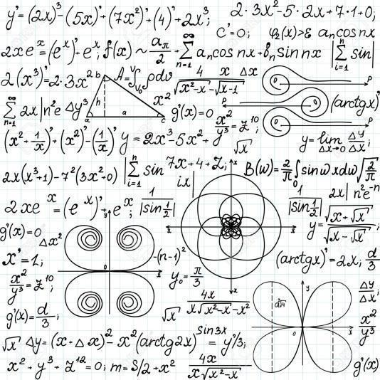
https://nrich.maths.org/
http://www.numberphile.com/
http://www.cut-the-knot.org/
https://madasmaths.com/

Spanish:
www.elpais.com - El Pais: Spanish national newspaper.
www.bbc.com/mundo - BBC Mundo: The BBC’s Spanish language news service.
www.elmundo.es - El Mundo: Spanish broadsheet with a high level of challenge.

www.20minutos.es – 20 Minutos: Spanish national newspaper.

www.diariosur.es – Diario Sur: Daily Spanish news service.

MFL – Spanish

Physics 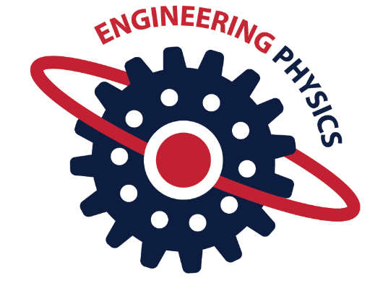

- Make yourself stand out by completing an online course:
https://www.futurelearn.com/courses/categories/science-engineering-and-maths-courses

- Teach yourself how to code:
https://www.codecademy.com/

- Problem Solving
This is the most important skill to develop if you are applying for the top universities, particularly if you will be sitting an entrance exam or attending an interview.
https://isaacphysics.org/ https://brilliant.org/ http://i-want-to-study-engineering.org/

- Summer Schools
Attending a summer school will allow you to develop the skills that admissions tutors are looking for and make you stand out from other applicants.

Insight into University – summer schools at universities around the country in many subjects, including Physics, Computer Science and Engineering.
https://www.etrust.org.uk/insight-into-university

Smallpeice Trust - summer schools covering subjects like motorsports engineering, astrophysics, design, programming and robotics and many more:
https://www.smallpeicetrust.org.uk/momentum-events

Birmingham University Physics Summer School:
https://www.birmingham.ac.uk/schools/physics/outreach/secondary-schools/summer-schools.aspx

- Suggested Reading
Universities will not expect you to have read any particular book, but they will expect you to have read beyond the A Level syllabus. These are just a selection – there are far more than I can list; choose any popular science book that interests you.
Engineering
- Sustainable Energy – Without the Hot Air by David J.C. MacKay
- How Do Wings Work? by Holger Babinsky (a paper published in the Institute of Physics journal Physics Education that is available as a free download from the iop
http://iopscience.iop.org/article/10.1088/0031-9120/38/6/001/meta)
- Engineering in Society edited by Rob Lawlor (An e-book published by the Royal Academy of Engineering that is available as a free (pdf) download from
https://www.raeng.org.uk/publications/reports/engineering-in-society)
- Engineering: A Beginner's Guide by Natasha McCarthy
- Structures – or Why Things Don't Fall Down by J.E. Gordon
- Cats' Paws and Catapults: Mechanical Worlds of Nature and People by Steven Vogel
- The Gecko's Foot: How Scientists are Taking a Leaf from Nature's Book by Peter Forbes
- Small Things Considered: Why There is No Perfect Design by Henry Petroski
- Understanding Flight by David W. Anderson and Scott Eberhart
- Think Like An Engineer by Guru Madhavan

Physics
- Stuff Matters by M. Miodownik
- Six Brief Lessons on Physics by Carlo Rovelli
- The World According to Physics by Jim Al-Khalili
- Quantum Theory Cannot Hurt You by Marcus Chown
- Quantum - Manjit Kumar
- Big Bang by Simon Singh
- Six Easy Pieces by Richard Feynman
- A Brief History of Time by Stephen Hawking
- The Universe in a Nutshell by Stephen Hawking
- The Elegant Universe by Brian Greene
- Physics of the Impossible by Michio Kaku
- Why does E=mc² by Brian Cox and Jeff Forshaw
- Human Universe by Brian Cox
- A Short History of Nearly Everything - Bill Bryson
- Great Physicists - William H. Cropper

Physics and Philosophy
An invitation to Philosophy by M Hollis
Think by S. Blackburn

- Other

Cheltenham Science Festival – lots of very interesting speakers and topics, and go along to the free exhibitions in the Town Hall

Podcasts – BBC Radio 4 – The Infinite Monkey Cage: https://www.bbc.co.uk/programmes/b00snr0w

TED Talks – Ideas about Physics: https://www.ted.com/topics/physics

Engineering Careers and Information: http://www.tomorrowsengineers.org.uk/

Astronomy. http://hubblesite.org/explore_astronomy/

The Institute of Physics. http://www.iop.org/

Physics careers and information: http://www.physics.org/

Psychology
Super-Curriculum
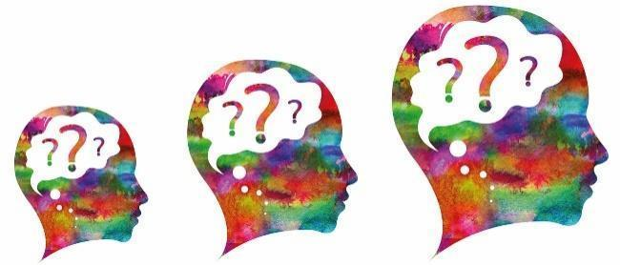

WATCHING

TED Talks https://www.ted.com/search?q=psychology
BPS (British Psychological Society) http://beta.bps.org.uk/
BBC documentaries http://www.bbc.co.uk/search?q=psychology
Channel 4 documentaries http://www.channel4.com/search?q=psychology&intcmp=header_predictive_search_seeall

FILMS
Beautiful Mind
Memento
Girl Interrupted
One Flew Over the Cuckoo's Nest
Fight Club
12 Angry Men
Rain Man
Coach Carter
Juror

LISTENING

All in the Mind BBC Radio 4 podcasts https://www.bbc.co.uk/programmes/b006qxx9/episodes/downloads

VISITS

Science museum http://www.sciencemuseum.org.uk/ Look out for exhibitions on Psychology topics.
Freud Museum https://www.freud.org.uk/ 20 Maresfield Gardens, London NW3 5SX
Cheltenham Science Festical - Early June each year

READING

JOURNALS
Weekly Psychological Research News https://digest.bps.org.uk/
Psychology Review is an excellent journal that is published for A-level Psychology Students www.hoddereducation.co.uk/psychologyreview
BOOKS
‘The Shock of the Fall’ – Nathan Filer
‘Henry’s Demons: Living with Schizophrenia’ – Patrick and Henry Cockburn
‘An Unquiet Mind’ – Kay Jamison
‘Sectioned: a life interrupted’ – John O’Donahue
‘The Rosie Project’ – Graeme Simsion
‘The Curious Incident of the Dog in the Night Time’ – Mark Haddon
'I’m Eve’ – Chris Sizemore
‘Electroboy: A Memoir of Mania’ – Andy Berhman
‘Brain on Fire’ – Sussanah Cahalan
‘Go Ask Alice’ – Anonymous
‘Jigsaw man’ – Paul Britton
‘Picking up the pieces’ – Paul Britton
‘Genie’ – Russ Rymer
‘How to Develop a Perfect Memory’ - Dominic O'Brien
‘The Art of Memory’ - Frances Yates
‘Your Memory’ - Kenneth Higbee
‘The Lucifer Effect’ – Phillip Zimbardo
‘Schindler’s List’ - Thomas Keneally
‘1984’ - George Orwell
‘The Individual in a Social World: Essays and Experiments’ - Stanley Milgram
‘We Need to Talk About Kevin’ – Lionel Shriver
‘The Man who Mistook his Wife for a Hat ‘ – Dr Oliver Sacks
'Elephants on Acid and other Bizarre Experiments' - Alex Boese
'Bad Science' - Ben Goldacre
'Opening Skinner's Box: Great Psychological Experiments of the Twentieth Century' - Laura Slater
'Psychology in Football' - Mark Nesti
'The Black Swan: The Impact of the Highly Improbable' - Nassim Nicholas Taleb
'The Blank Slate' - Stephen Pinker
'Without Conscience: The Disturbing World of the Psychopaths Among Us' - Robert.D Hare
'Working Memory, Thought and Action' - Alan Baddeley
'Obedience to Authority' - Stanley Milgram

SOCIOLOGY
SUPER CURRICULUM

Watching (Films/Programmes)
A regular watcher of the news will be up to date with current affairs and social issues and will be able to apply many of the theories and concepts covered in class to the real world.
Below are some handpicked films and documentaries, with the sociological themes/topics in brackets.
Jesus Camp (religion, alienation, oppression, childhood)
The UP Series of documentaries, 7UP, 14UP…49UP etc. (longitudinal research, childhood, families, poverty)
My Scientology Movie (religion, globalisation, class, crime)
Louie Theroux Documentaries (media, celebrity, culture, Western society)
Inside Death Row with Trevor MacDonald (punishment, prisons, class, ethnicity, crime reduction)
Unequal Opportunities BBC Documentary (Education, marketization, selection policies, deprivation)
Enron: The Smartest Guys in the Room (Marxism, Corruption, Globalisation, Corporate Crime)
Black Like Me (ethnicity, USA, covert observations, ethical issues)
Quiet Rage: The Stanford Prison Experiment (lab experiments, ethical issues)
East is East (extended family, Asian families, Gay/Lesbian culture)
Ken Loach films such as Kes and I Daniel Blake (poverty, underclass, subcultures, benefits)
OJ Simpson: Made in America (ethnicity, criminal justice, celebrity, murder, gender and crime)
TED talks on sociology: https://www.ted.com/talks?sort=relevance&q=social+equality

Reading
The BBC news website is worth a daily visit, or set up your phone to receive regular alerts, particularly the Economy tab.
Reading the Times, Guardian, Telegraph, and Independent (either online or broadsheet) will provide you with good coverage of social issues. The Guardian has dedicated sections online of our main topics that are easy to access (Family, Education, Religion and Crime)
Sociology Review – This monthly magazine is specifically targeted at A Level students. It cover topics that are in the A-level specification and provides interesting examples of areas that have been covered in class. It also offer extension material, model examination answers and methods of improving exam performance. The articles are mostly written by experienced teachers and examiners. It can be ordered online, borrowed from the Head of Department or read in the School library.

Reading continued:
Sociology texts
The Sociological Imagination by C. Wright Mills
Economy and Society: an Outline of Interpretive Sociology by Max Weber
The Presentation of Self in Everyday Life by Erving Goffman
‘Sociology related’ books:
Pride and Prejudice by Jane Austen
The Mandarins by Simone de Beauvoir
A Streetcar Named Desire by Tennessee Williams
American Psycho by Brett Easton Ellis
Rivers of London by Ben Aaronovitch
Catcher in the Rye by JD Salinger
Stoner by John Williams
Bright Lights, Big City by Jay McInerny

Listening / Podcasts
University of Oxford: Department of Sociology Podcasts
https://podcasts.ox.ac.uk/series/department-sociology-podcasts
AQA: Podcasts for AS and A-level Sociology
http://www.aqa.org.uk/resources/sociology/as-and-a-level/sociology/teach/podcasts-for-asand-a-level-sociology
Thinking Allowed: Radio 4
https://www.bbc.co.uk/programmes/b006qy05/episodes/downloads
Also, tuning into Radio 4’s Today programme between 6.00 am and 9.00 am any weekday would help you to have updated news and current affairs
Give Methods a Chance: https://thesocietypages.org/methods/
'Give Methods a Chance' explores the research methods used by sociologists, focusing on techniques both qualitative and quantitative. This podcast is produced by sociology site 'The Society Pages'.
'The Society Pages' is an open-access social science project presenting articles, blogs, and podcasts with sociology news. Divided into various areas of sociological concern, such as race and politics, it keeps readers abreast of new and engaging research and work.
Independent Thought & Freedom - Kirk Meighoo https://podcasts.apple.com/tt/podcast/independent-thought-freedom/id1446388269

Visits
The V&A Museum of Childhood, Tate Modern and The Science Museum are interesting places to visit for students looking to have an understanding of key themes and topics within Sociology (such as Childhood, Modernism and Technological change in society)
www.vam.ac.uk/moc
www.tate.org.uk/visit/tate-modern
www.sciencemuseum.org.uk

