Welcome to Economics at Henley Bank Sixth Form!

We will be studying the Pearson Edexcel Level 3 Advanced GCE in Economics A specification over the two years, including the following themes and topics:

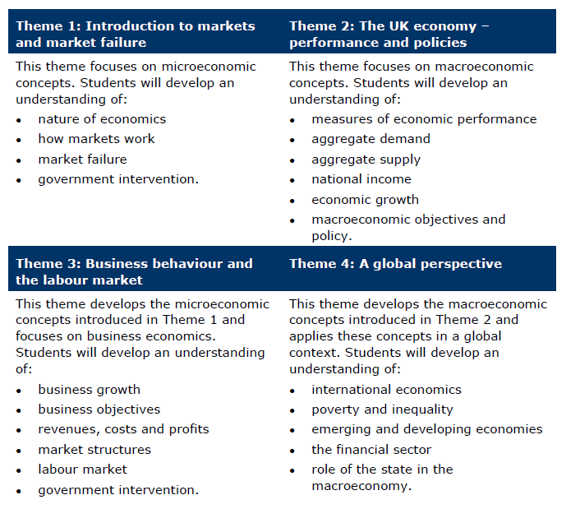

Economics is a social science which means it studies society and relationships between people. Economists analyse many different aspects of human behaviour and decision-making within and between markets, organisations and countries.
Economics is not really about money, instead it is about the decisions that we take in our everyday life – from who to date, whether to buy a house or which job to apply for. For every choice we make as individuals or as a society, there is a cost and a benefit. Spend some time over the summer break on the following activities, books, podcasts and websites:

- Watch short videos on the Tutor2U website to understand key information you will need for A level economics:
https://ondemand.tutor2u.net/students/introduction-to-edexcel-a-level-economics-getting-started

- This website contains relevant topics and past papers, which will give you some ideas about what exam questions look like.
https://wearequrious.com/a-level-economics-notes-questions-edexcel/

- Podcasts: Look up the podcasts listed below and listen to an episode that sounds interesting. Make a note of different perspectives and opinions.
Available on Spotify:
- Economics Explained
- The Economist Podcast

