Welcome to Geography at Henley Bank Sixth Form!

We will be studying the AQA A Level specification over the two years, including the following topics:

- Water and Carbon Cycles
- Coastal Systems and Landscapes
- Hazards
- Global Systems and Governance
- Changing Places
- Contemporary Urban Environments
- Geography Fieldwork NEA

Geography is a fascinating subject about the environment, how places differ, how physical systems work and about how people interact with the world. Geography is about real-world events, their impacts and their different interpretations.
Geography looks at the ‘big ideas’ in the world and how people strive to make our world a better place to live in. We potentially face dramatic changes to our world through climate change. Learning about physical process such as the carbon cycle helps us understand the role of energy use in influencing climate change and importantly, helps us make judgements on the arguments presented in the media.
Spend some time over the summer break on the following activities, books, podcasts and websites:

- Pick one interesting news story over the summer which is linked to one of the Geography Topics on the A level course. Make a few notes using the guidance below so you can give a short 5-minute summary of the news story to the rest of the class in September.
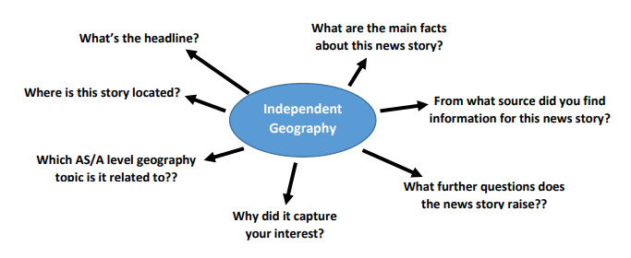

- Keep a detailed record of tectonic hazards, (earthquakes, volcanic eruptions and tsunamis) that happen over the summer break. You could keep this as a diary.

  - Include the date, time, location, and magnitude of the event, impact of the event on the people, environment and economy.
  - This should include specific facts and you should quote the source of your information.
Good places to research are USGS (United States Geological Survey) website, the newspapers and the BBC website and news.

- Podcasts
  - Costing the Earth- There are some great podcasts here to pick from on a wide variety of geographical issues. https://www.bbc.co.uk/programmes/b006r4wn/episodes/player (many topics including climate change, carbon, urban greening, deforestation, alternative powers, plastics (etc)
  - Royal Geographical Society – ‘Ask the Geographer podcasts’ - https://www.rgs.org/schools/resources-for-schools/ask-the-geographer-podcasts
a fantastic set of podcasts to keep A Level study up to date with the latest geographical research - pick out some that interest you.

- Books
Further reading – There is a plethora of books out there linked to Geography. Below there are many books you could be spending time reading. All are available on Amazon and are overall quite cheap (look at the second-hand option or come and ask me as I have quite a few of them). We recommend you spend the summer reading at least one.



