
Welcome to Maths at Henley Bank Sixth Form!

We will be studying the Edexcel A Level specification over the two years, including the following topics:

Course Content | Course Content
Surds and Indices | Sequences and Series
Circles | Advanced Trigonometry
Algebra and Functions | Exponential and Logarithms
Coordinate Geometry | More Complex Differentiation and Integration
Basic Differentiation and  Integration | Functions
Trigonometry | Proof
Mechanics | Mechanics
Statistics | Statistics

The new A Level Maths course allows students to develop their problem solving, reasoning and modelling skills acquired throughout GCSE. Students will be given the opportunity to explore how Statistics and Mechanics can be applied to real life, as well as developing their understanding of Pure Mathematics. Utilising modern technologies, the A level Mathematics course allows the use of Mathematical software to enhance student’s learning experience. This gives them a valuable tool to check their reasoning and saves precious time in the exam, without being overcome with arithmetic calculations.

Our specialist A level Maths teachers support and guide students throughout their two years of A level Maths study, offering after school revision and support in study periods to all students. Edexcel A level Maths comprises 3 two hour papers: 2 Pure and a combined Mechanics and Statistics, all to be sat at the end of two years of study.

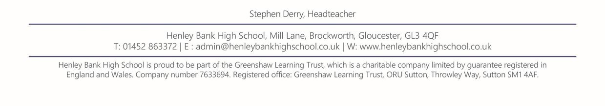
To succeed in A level maths it is imperative that you are practising maths all the time, and to make sure we start in the best place possible, we would like that to begin this summer. Please work your way through the summer work activities, which are designed to help with the transition from GCSE to A level.

Expanding brackets
and simplifying expressions
A LEVEL LINKS
Scheme of work: 1a. Algebraic expressions – basic algebraic manipulation, indices and surds

Key points
- When you expand one set of brackets you must multiply everything inside the bracket by what is outside.
- When you expand two linear expressions, each with two terms of the form ax + b, where
a ≠ 0 and b ≠ 0, you create four terms. Two of these can usually be simplified by collecting like terms.

Examples
Example 1 Expand 4(3x − 2)

4(3x − 2) = 12x − 8 | Multiply everything inside the bracket by the 4 outside the bracket
Example 2 Expand and simplify 3(x + 5) − 4(2x + 3)

3(x + 5) − 4(2x + 3)  = 3x + 15 − 8x – 12  = 3 − 5x | - Expand each set of brackets separately by multiplying (x + 5) by 3 and (2x + 3) by −4  - Simplify by collecting like terms: 3x − 8x = −5x and 15 − 12 = 3
Example 3 Expand and simplify (x + 3)(x + 2)

(x + 3)(x + 2)  = x(x + 2) + 3(x + 2)  = x² + 2x + 3x + 6  = x² + 5x + 6 | - Expand the brackets by multiplying (x + 2) by x and (x + 2) by 3  - Simplify by collecting like terms: 2x + 3x = 5x
Example 4 Expand and simplify (x − 5)(2x + 3)

(x − 5)(2x + 3)  = x(2x + 3) − 5(2x + 3)  = 2x² + 3x − 10x − 15  = 2x² − 7x − 15 | - Expand the brackets by multiplying (2x + 3) by x and (2x + 3) by −5  - Simplify by collecting like terms: 3x − 10x = −7x

Practice
1
Watch out!
When multiplying (or dividing) positive and negative numbers, if the signs are the same the answer is ‘+’; if the signs are different the answer is ‘–’.
Expand.
a  c | 3(2x − 1)  −(3xy − 2y²) | b | −2(5pq + 4q²)
Expand and simplify.
a | 7(3x + 5) + 6(2x – 8) | b | 8(5p – 2) – 3(4p + 9)
c | 9(3s + 1) –5(6s – 10) | d | 2(4x – 3) – (3x + 5)

2

- Expand.
a 3x(4x + 8) b 4k(5k² – 12)
c –2h(6h² + 11h – 5) d –3s(4s² – 7s + 2)

- Expand and simplify.
a 3(y² – 8) – 4(y² – 5) b 2x(x + 5) + 3x(x – 7)
c 4p(2p – 1) – 3p(5p – 2) d 3b(4b – 3) – b(6b – 9)

- Expand 1 (2y – 8)
2

- Expand and simplify.
a 13 – 2(m + 7) b 5p(p² + 6p) – 9p(2p – 3)

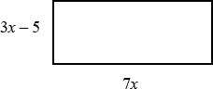
- The diagram shows a rectangle.
Write down an expression, in terms of x, for the area of the rectangle.
Show that the area of the rectangle can be written as 21x² – 35x

- Expand and simplify.

a | (x + 4)(x + 5) | b | (x + 7)(x + 3)
c | (x + 7)(x – 2) | d | (x + 5)(x – 5)
e | (2x + 3)(x – 1) | f | (3x – 2)(2x + 1)
g | (5x – 3)(2x – 5) | h | (3x – 2)(7 + 4x)
i | (3x + 4y)(5y + 6x) | j | (x + 5)²
k | (2x − 7)² | l | (4x − 3y)²

Extend
- Expand and simplify (x + 3)² + (x − 4)²

- Expand and simplify.

⎛ 1 ⎞⎛ 2 ⎞
⎛ 1 ⎞2

a ⎜ x + x ⎟⎜ x − x ⎟ b ⎜ x + x ⎟
⎝ ⎠⎝ ⎠ ⎝ ⎠

Answers

1 | a  c | 6x – 3  –3xy + 2y² | b | –10pq – 8q²
2 | a | 21x + 35 + 12x – 48 = 33x – 13
 | b | 40p – 16 – 12p – 27 = 28p – 43
 | c | 27s + 9 – 30s + 50 = –3s + 59 = 59 – 3s
 | d | 8x – 6 – 3x – 5 = 5x – 11
3 | a c | 12x² + 24x b  10h – 12h³ – 22h² d |  | 20k³ – 48k  21s² – 21s³ – 6s
4 | a c | –y² – 4 b  2p – 7p² d |  | 5x² – 11x  6b²
5 | y – 4
6 | a | –1 – 2m b |  | 5p³ + 12p² + 27p
7 7x(3x – 5) = 21x² – 35x

8 | a | x² + 9x + 20 | b | x² + 10x + 21
 | c | x² + 5x – 14 | d | x² – 25
 | e | 2x² + x – 3 | f | 6x² – x – 2
 | g | 10x² – 31x + 15 | h | 12x² + 13x – 14
 | i | 18x² + 39xy + 20y² | j | x² + 10x + 25
 | k | 4x² − 28x + 49 | l | 16x² − 24xy + 9y²

9 2x² − 2x + 25

10 a
x² −1− 2
x2
b x² + 2 + 1
x2

Surds and rationalising the denominator
A LEVEL LINKS
Scheme of work: 1a. Algebraic expressions – basic algebraic manipulation, indices and surds

Key points
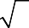
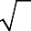
- A surd is the square root of a number that is not a square number, for example 2, 3, 5, etc.
- Surds can be used to give the exact value for an answer.

- ​
- ​
= a ×
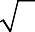
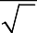
=
ab
b
a
b
a
b

- To rationalise the denominator means to remove the surd from the denominator of a fraction.
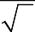
- To rationalise a you multiply the numerator and denominator by the surd
b
b
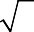
- To rationalise a you multiply the numerator and denominator by b −
b + c
c

Examples
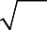
Example 1 Simplify
50

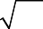  50 = 25 × 2  = 25 × 2  = 5 × 2  = 5 2 | - Choose two numbers that are factors of 50. One of the factors must be a square number  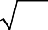  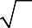  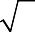  - Use the rule ab = a × b  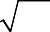  - Use 25 = 5

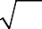
Example 2 Simplify − 2
147
12

147 − 2 12  = 49 × 3 − 2 4 × 3  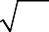  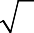  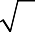  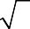  = 49 × 3 − 2 4 × 3  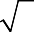  = 7 × 3 − 2 × 2 × 3  = 7 3 − 4 3  = 3 3 | - Simplify 147 and 2 12 . Choose two numbers that are factors of 147 and two numbers that are factors of  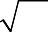  12. One of each pair of factors must  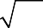  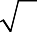  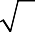  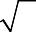  be a square number  - Use the rule ab = a × b  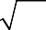  - Use 49 = 7 and 4 = 2  - Collect like terms

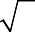
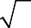
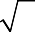
Example 3 Simplify (
7
7
+ 2 )(
− 2 )

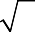  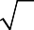  ( 7 + 2 )( 7 − 2 )  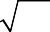  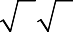  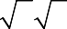  = 49 − 7 2 + 2 7 − 4  = 7 – 2  = 5 | - Expand the brackets. A common mistake here is to write ( 7 )2 = 49  - Collect like terms:  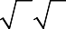  − 7 2 + 2 7  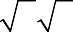  = − 7 2 + 7 2 = 0

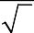
Example 4 Rationalise 1
3

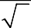  1 = 1 × 3  3 3 3  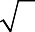  = 1× 3  9  = 3  3 | - Multiply the numerator and denominator by 3  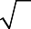  - Use 9 = 3

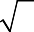
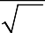
Example 5 Rationalise and simplify
2
12

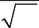  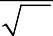  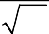  2 = 2 × 12  12 12 12  = 2 × 4 × 3  12  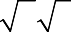  = 2 2 3  12  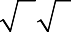  = 2 3  6 | 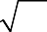  - Multiply the numerator and denominator by 12  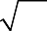  - Simplify 12 in the numerator. Choose two numbers that are factors of 12. One of the factors must be a square number  - Use the rule ab = a × b  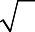  - Use 4 = 2  - Simplify the fraction:  2 simplifies to 1  12 6

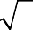
Example 6 Rationalise and simplify 3
2 + 5

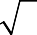  3 = 3 × 2 − 5  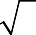  2 + 5 2 + 5 2 − 5  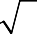  3(2 − 5 )  = (2 + 5 )(2 − 5 )  = 6 − 3 5  4 + 2 5 − 2 5 − 5  = 6 − 3 5  −1  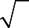  = 3 5 − 6 | - Multiply the numerator and denominator by 2 − 5  - Expand the brackets  - Simplify the fraction  - Divide the numerator by −1 Remember to change the sign of all terms when dividing by −1

Practice
- Simplify.
Hint
One of the two numbers you choose at the start must be a square number.

a | 45 | b | 125
c | 48 | d | 175
e | 300 | f | 28
g | 72 | h | 162

- Simplify.
a +
72
162

b − 2
45
5
Watch out!
Check you have chosen the highest square number at the start.

c | 50 − | 8 | d | 75 − 48
e | 2 28 + 28 |  | f | 2 12 − 12 + | 27

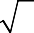
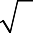
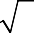
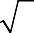
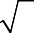
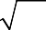
- Expand and simplify.
2
2

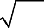
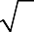
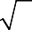
a (
45
+ 3)(
− 3) b
(3 +
3)(5 −
12)

c (4 −
5)(
+ 2) d
(5 +
2)(6 − 8)

- Rationalise and simplify, if possible.

a | 1  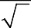  5 | b | 1  11
c | 2  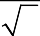  7 | d | 2  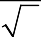  8
e | 2  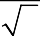  2 | f | 5  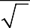  5
g | 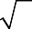  8  24 | h | 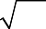  5  45

- Rationalise and simplify.
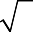
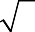
a 1 b 2 c 6
3 − 5
4 + 3
5 − 2

Extend
- Expand and simplify (

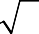
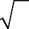
+ y )(
x

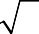
− y )
x

- Rationalise and simplify, if possible.
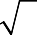
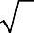
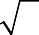
a 1 b 1
9 − 8
x − y

Answers

1 | a | 3 5 | b | 5 | 5
 | c | 4 3 | d | 5 | 7
 | e | 10 3 | f | 2 | 7
 | g | 6 2 | h | 9 | 2
2 | a | 15 2 | b | 5
 | c | 3 2 | d | 3
 | e | 6 7 | f | 5 3
3 | a | −1 | b | 9 − 3
 | c | 10 5 − 7 | d | 26 − 4 2
4 | a | 5  5 | b | 11  11
 | c | 2 7  7 | d | 2  2
 | e | 2 | f | 5
 | g | 3  3 | h | 1  3

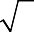
5 a 3 + 5
4
b 2(4 − 3)
13
c 6(5 + 2) 23

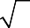
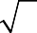
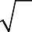
- x − y
x
+ y

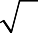
- a 3 + 2
2
b x − y

Rules of indices
A LEVEL LINKS
Scheme of work: 1a. Algebraic expressions – basic algebraic manipulation, indices and surds

Key points
- a^{m} × a^{n} = a^{m} ⁺ ^{n}

- am =
an

am−n

- (a^{m})^{n} = a^{mn}
- a⁰ = 1
1
- an = i.e. the nth root of a
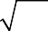
- a n = = ( n a )
n a
n am
m m
- a^{−m} = 1
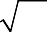
am
16

- The square root of a number produces two solutions, e.g.

Examples
Example 1 Evaluate 10⁰
= ±4 .

10⁰ = 1 | Any value raised to the power of zero is equal to 1

1
Example 2 Evaluate 92

1  92 = 9  = 3 | 1  Use the rule an = ^{n} a

2
Example 3 Evaluate 27 3

2 2  273 = ( 3 27 )  = 3²  = 9 | m m  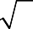  - Use the rule a n = ( n a )  - Use ³ 27 = 3

Example 4 Evaluate 4⁻²

4−2 = 1  42  = 1  16 | - Use the rule a^{−m} = 1  am  - Use 4² = 16

Example 5 Simplify
6x⁵ 2x²

6x⁵  = 3x³  2x² | am = m−n  6 ÷ 2 = 3 and use the rule a to  an  x5 = 5 − 2 3  give x = x  x2

Example 6 Simplify
x³ × x⁵ x4

x3 × x5 = x3+5 = x8 x4 x4 x4  = x8 − 4 = x4 | - Use the rule a^{m} × a^{n} = a^{m+n}  am = m−n  - Use the rule a  an

Example 7 Write 1
3x
as a single power of x

1 = 1 x−1  3x 3 | Use the rule 1 = a^{−m} , note that the  am  fraction 1 remains unchanged  3

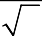
Example 8 Write 4
x
as a single power of x

4 = 4  1  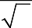  x x 2  - 1  = 4x 2 | 1  - Use the rule an = ^{n} a  - Use the rule 1 = a^{−m}  am

Practice
- Evaluate.
a 14⁰ b 3⁰ c 5⁰ d x⁰

- Evaluate.
1 1 1 1

a 49 2
b 643
c 1253
d 16 4

- Evaluate.
3 5 3 3

a 252
b 83
c 49 2
d 16 4

- Evaluate.
a 5–2 b 4–3 c 2–5 d 6–2

- Simplify.
3x² × x³
10x⁵

  - 2x²
3x × 2x³
- 2x³
y2
e
1

y 2 × y
3
  - 2x² × x
7x³ y²
Watch out!
Remember that any value raised to the power of zero is 1. This is the rule a⁰ = 1.
d
14x⁵ y
1
- c 2
c² × c 3
2

(2x )
2
x 2 × x 2

- 4x⁰ h x⁻² × x³
1
3

- Evaluate.
− 1

− 2 − 1

  - 4 2
1

b 27 3
− 1

c 9 2 × 2³
− 2

d 164 × 2⁻³
⎛ 9 ⎞ 2
e ⎜ ⎟
16
⎝ ⎠
⎛ 27 ⎞ 3
f ⎜ ⎟
64
⎝ ⎠

- Write the following as a single power of x.
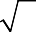
  - 1 b 1 c
4 x
x x⁷
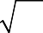
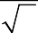
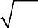
- e 1 f 1
5 x2
3 x
3 x2

- Write the following without negative or fractional powers.
1

  - x−3
2
  - x⁰ c x 5
− 1 − 3

- x 5
- x 2
- x 4

- Write the following in the form ax^{n}.

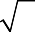
  - 5
x
  - 2 c
x3
1

3x⁴

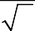
d 2 e 4 f 3
x
3 x

Extend

- Write as sums of powers of x.
x⁵ + 1

₂ ⎛ 1 ⎞

₋₄ ⎛ ₂ 1 ⎞

  - x2
  - x ⎜ x + x ⎟
  - x ⎜ x
+ x3 ⎟

⎝ ⎠ ⎝ ⎠

Answers

1 | a | 1 | b | 1 | c | 1 | d | 1
2 | a | 7 | b | 4 | c | 5 | d | 2
3 | a | 125 | b | 32 | c | 343 | d | 8
4 | a | 1  25 | b | 1  64 | c | 1  32 | d | 1  36

3x³
- a
2

b 5x²

c 3x |  | d | y  2x²
e | 1  y 2 | f | c–3
g | 2x⁶ | h | x

- a 1 b 1
2 9
  - 1 e 4
4 3
c 8
3
f 16
9

1
- a x^{–1} b x^{–7} c x 4

2
  - x 5
− 1
  - x 3
− 2
  - x 3

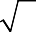
- a 1
5 x
b | 1 |  | c
e |  | 1  x | f

x3

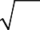
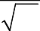
d 1
5 x2
4 x3

1
- a 5x 2

− 1

b 2x^{–3} c

− 1

1 x−4
3

- 2x 2
- 4x 3
- 3x⁰

- a
x3 + x−2
b x³ + x
c x−2 + x−7

Factorising expressions
A LEVEL LINKS
Scheme of work: 1b. Quadratic functions – factorising, solving, graphs and the discriminants

Key points
- Factorising an expression is the opposite of expanding the brackets.
- A quadratic expression is in the form ax² + bx + c, where a ≠ 0.
- To factorise a quadratic equation find two numbers whose sum is b and whose product is ac.
- An expression in the form x² – y² is called the difference of two squares. It factorises to (x – y)(x + y).

Examples
Example 1 Factorise 15x²y³ + 9x⁴y

15x²y³ + 9x⁴y = 3x²y(5y² + 3x²) | The highest common factor is 3x²y. So take 3x²y outside the brackets and then divide each term by 3x²y to find the terms in the brackets

Example 2 Factorise 4x² – 25y²

4x² – 25y² = (2x + 5y)(2x − 5y) | This is the difference of two squares as the two terms can be written as  (2x)² and (5y)²

Example 3 Factorise x² + 3x – 10

b = 3, ac = −10  So x² + 3x – 10 = x² + 5x – 2x – 10  = x(x + 5) – 2(x + 5)  = (x + 5)(x – 2) | - Work out the two factors of  ac = −10 which add to give b = 3  (5 and −2)  - Rewrite the b term (3x) using these two factors  - Factorise the first two terms and the last two terms  - (x + 5) is a factor of both terms

Example 4 Factorise 6x² − 11x − 10

b = −11, ac = −60  So  6x² − 11x – 10 = 6x² − 15x + 4x – 10  = 3x(2x − 5) + 2(2x − 5)  = (2x – 5)(3x + 2) | - Work out the two factors of  ac = −60 which add to give b = −11 (−15 and 4)  - Rewrite the b term (−11x) using these two factors  - Factorise the first two terms and the last two terms  - (2x − 5) is a factor of both terms

Example 5 Simplify
x² − 4x − 21

2x² + 9x + 9

x² − 4x − 21  2x² + 9x + 9  For the numerator:  b = −4, ac = −21  So  x² − 4x – 21 = x² − 7x + 3x – 21  = x(x − 7) + 3(x − 7)  = (x – 7)(x + 3)  For the denominator:  b = 9, ac = 18  So  2x² + 9x + 9 = 2x² + 6x + 3x + 9  = 2x(x + 3) + 3(x + 3)  = (x + 3)(2x + 3)  So  x² − 4x − 21 = (x − 7)(x + 3)  2x² + 9x + 9 (x + 3)(2x + 3)  = x − 7  2x + 3 | - Factorise the numerator and the denominator  - Work out the two factors of  ac = −21 which add to give b = −4 (−7 and 3)  - Rewrite the b term (−4x) using these two factors  - Factorise the first two terms and the last two terms  - (x − 7) is a factor of both terms  - Work out the two factors of  ac = 18 which add to give b = 9 (6 and 3)  - Rewrite the b term (9x) using these two factors  - Factorise the first two terms and the last two terms  - (x + 3) is a factor of both terms  - (x + 3) is a factor of both the numerator and denominator so cancels out as a value divided by itself is 1

Practice
1 | Factorise.  a 6x⁴y³ – 10x³y⁴ |  |  |  | b | 21a³b⁵ + 35a⁵b² | Hint
c |  | 25x²y² – 10x³y² + 15x²y³ |  |  |  |  | Take the highest  common factor
2 | Factorise |  |  |  |  |  | outside the bracket.
a |  | x² + 7x + 12 |  |  | b | x² + 5x – 14
c |  | x² – 11x + 30 |  |  | d | x² – 5x – 24
e |  | x² – 7x – 18 |  |  | f | x² + x –20
g |  | x² – 3x – 40 |  |  | h | x² + 3x – 28
3 | Factorise
a |  | 36x² – 49y² |  |  | b | 4x² – 81y²
c |  | 18a² – 200b²c²
4 | Factorise
a |  | 2x² + x –3 |  |  | b | 6x² + 17x + 5
c |  | 2x² + 7x + 3 |  |  | d | 9x² – 15x + 4
e |  | 10x² + 21x + 9 |  |  | f | 12x² – 38x + 20
5 | Simplify the algebraic fractions.
a |  | 2x² + 4x x² − x |  |  | b | x² + 3x
c |  | x² − 2x − 8  x² − 4x |  |  | d | x² − 5x
e |  | x² − x −12  x² − 4x |  |  | f | 2x² + 14x
6 | Simplify
a |  | 9x² −16  3x² + 17x − 28 |  |  | b | 2x² − 7x −15
c |  | 4 − 25x²  10x² −11x − 6 |  |  | d | 6x² − x −1
Extend
7 | Simplify |  |  | x² + 10x + 25
8 | Simplify |  | (x + 2)² + 3(x + 2)²  x² − 4

x² + 2x − 3

x² − 25

2x² + 4x − 70

3x² −17x + 10

2x² + 7x − 4

Answers

1 | a c | 2x³y³(3x – 5y) 5x²y²(5 – 2x + 3y) | b | 7a³b²(3b³ + 5a²)
2 | a | (x + 3)(x + 4) | b | (x + 7)(x – 2)
 | c | (x – 5)(x – 6) | d | (x – 8)(x + 3)
 | e | (x – 9)(x + 2) | f | (x + 5)(x – 4)
 | g | (x – 8)(x + 5) | h | (x + 7)(x – 4)
3 | a | (6x – 7y)(6x + 7y) | b | (2x – 9y)(2x + 9y)
 | c | 2(3a – 10bc)(3a + 10bc)
4 | a | (x – 1)(2x + 3) | b | (3x + 1)(2x + 5)
 | c | (2x + 1)(x + 3) | d | (3x – 1)(3x – 4)
 | e | (5x + 3)(2x +3) | f | 2(3x – 2)(2x –5)
5 | a  c e | 2(x + 2)  x − 1  x + 2  x  x + 3  x | b  d f | x  x − 1  x  x + 5  x  x − 5
6 | a c | 3x + 4  x + 7  2 − 5x  2x − 3 | b d | 2x + 3  3x − 2  3x + 1  x + 4
7 | (x + 5)
8 | 4(x + 2)  x − 2

Completing the square
A LEVEL LINKS
Scheme of work: 1b. Quadratic functions – factorising, solving, graphs and the discriminants

Key points
- Completing the square for a quadratic rearranges ax² + bx + c into the form p(x + q)² + r
- If a ≠ 1, then factorise using a as a common factor.

Examples
Example 1 Complete the square for the quadratic expression x² + 6x − 2

x² + 6x − 2  = (x + 3)² − 9 − 2  = (x + 3)² − 11 | - Write x² + bx + c in the form  ⎛ b ⎞2 ⎛ b ⎞2  ⎜ x + ⎟ − ⎜ ⎟ + c  ⎝ 2 ⎠ ⎝ 2 ⎠  - Simplify

Example 2 Write 2x² − 5x + 1 in the form p(x + q)² + r

2x² − 5x + 1  = 2⎛ x² − 5 x ⎞ + 1  ⎜ 2 ⎟  ⎝ ⎠  ⎡⎛ 5 ⎞² ⎛ 5 ⎞² ⎤  = 2 ⎢⎢⎜ x − 4 ⎟ − ⎜ 4 ⎟ ⎥⎥ + 1  ⎣⎝ ⎠ ⎝ ⎠ ⎦  ⎛ 5 ⎞² 25  = 2⎜ x − 4 ⎟ − 8 + 1  ⎝ ⎠  ⎛ 5 ⎞² 17  = 2⎜ x − 4 ⎟ − 8  ⎝ ⎠ | - Before completing the square write  ax² + bx + c in the form  a ⎛ x² + b x ⎞ + c  ⎜ a ⎟  ⎝ ⎠  - Now complete the square by writing  x² − 5 x in the form  2  ⎛ b ⎞² ⎛ b ⎞²  ⎜ x + ⎟ − ⎜ ⎟  ⎝ 2 ⎠ ⎝ 2 ⎠  - Expand the square brackets – don’t  ⎛ 5 ⎞²  forget to multiply ⎜ 4 ⎟ by the  ⎝ ⎠  factor of 2  - Simplify

Practice
- Write the following quadratic expressions in the form (x + p)² + q

a | x² + 4x + 3 | b | x² – 10x – 3
c | x² – 8x | d | x² + 6x
e | x² – 2x + 7 | f | x² + 3x – 2

- Write the following quadratic expressions in the form p(x + q)² + r

a | 2x² – 8x – 16 | b | 4x² – 8x – 16
c | 3x² + 12x – 9 | d | 2x² + 6x – 8

- Complete the square.
a 2x² + 3x + 6 b 3x² – 2x
c 5x² + 3x d 3x² + 5x + 3

Extend
- Write (25x² + 30x + 12) in the form (ax + b)² + c.

Answers

2⎜ x + 4 ⎟ +
1 | a  c | (x + 2)² – 1  (x – 4)² – 16 |  | b  d |  | (x – 5)² – 28  (x + 3)² – 9
2 | e  a | (x – 1)² + 6  2(x – 2)² – 24 |  | f  b |  | ⎛ 3 ⎞² 17  ⎜ x + ⎟ −  ⎝ 2 ⎠ 4  4(x – 1)² – 20
 | c | 3(x + 2)² – 21 |  | d |  | ⎛ 3 ⎞² 25 2⎜ x + ⎟ −  ⎝ 2 ⎠ 2
3 | a | ⎛ 3 ⎞²  ⎝ ⎠ |  | 39  8 | b | ⎛ 1 ⎞² 1 3⎜ x − 3 ⎟ − 3  ⎝ ⎠
c |  | ⎛ 3 ⎞²  ⎝ ⎠ | − | 9  20 | d | ⎛ 5 ⎞²  ⎝ ⎠ | + | 11  12
4 | (5x + 3)² + 3

5⎜ x + 10 ⎟ 3⎜ x + 6 ⎟

Solving quadratic equations by factorisation
A LEVEL LINKS
Scheme of work: 1b. Quadratic functions – factorising, solving, graphs and the discriminants

Key points
  - A quadratic equation is an equation in the form ax² + bx + c = 0 where a ≠ 0.
  - To factorise a quadratic equation find two numbers whose sum is b and whose products is ac.
  - When the product of two numbers is 0, then at least one of the numbers must be 0.
  - If a quadratic can be solved it will have two solutions (these may be equal).

Examples
Example 1 Solve 5x² = 15x

5x² = 15x  5x² − 15x = 0  5x(x − 3) = 0  So 5x = 0 or (x − 3) = 0  Therefore x = 0 or x = 3 | - Rearrange the equation so that all of the terms are on one side of the equation and it is equal to zero.  Do not divide both sides by x as this would lose the solution x = 0.  - Factorise the quadratic equation. 5x is a common factor.  - When two values multiply to make zero, at least one of the values must be zero.  - Solve these two equations.
Example 2 Solve x² + 7x + 12 = 0

x² + 7x + 12 = 0  b = 7, ac = 12  x² + 4x + 3x + 12 = 0 x(x + 4) + 3(x + 4) = 0 (x + 4)(x + 3) = 0  So (x + 4) = 0 or (x + 3) = 0  Therefore x = −4 or x = −3 | - Factorise the quadratic equation. Work out the two factors of ac = 12 which add to give you b = 7.  (4 and 3)  - Rewrite the b term (7x) using these two factors.  - Factorise the first two terms and the last two terms.  - (x + 4) is a factor of both terms.  - When two values multiply to make zero, at least one of the values must be zero.  - Solve these two equations.

Example 3 Solve 9x² − 16 = 0

9x² − 16 = 0  (3x + 4)(3x – 4) = 0  So (3x + 4) = 0 or (3x – 4) = 0  x = − 4 or x = 4  3 3 | - Factorise the quadratic equation. This is the difference of two squares as the two terms are (3x)² and (4)².  - When two values multiply to make zero, at least one of the values must be zero.  - Solve these two equations.
Example 4 Solve 2x² − 5x − 12 = 0

b = −5, ac = −24  So 2x² − 8x + 3x – 12 = 0 2x(x − 4) + 3(x − 4) = 0 (x – 4)(2x + 3) = 0  So (x – 4) = 0 or (2x +3) = 0  x = 4 or x = − 3  2 | - Factorise the quadratic equation. Work out the two factors of ac = −24 which add to give you b = −5.  (−8 and 3)  - Rewrite the b term (−5x) using these two factors.  - Factorise the first two terms and the last two terms.  - (x − 4) is a factor of both terms.  - When two values multiply to make zero, at least one of the values must be zero.  - Solve these two equations.
Practice
1 | Solve  a 6x² + 4x = 0 | b | 28x² – 21x = 0
 | c x² + 7x + 10 = 0  e x² – 3x – 4 = 0  g x² – 10x + 24 = 0 i x² + 3x – 28 = 0 k 2x² – 7x – 4 = 0 | d f h j l | x² – 5x + 6 = 0 x² + 3x – 10 = 0 x² – 36 = 0  x² – 6x + 9 = 0 3x² – 13x – 10 = 0
2 | Solve  a x² – 3x = 10 | b | x² – 3 = 2x
 | c x² + 5x = 24  e x(x + 2) = 2x + 25  g x(3x + 1) = x² + 15 | d  f h | x² – 42 = x  x² – 30 = 3x – 2 3x(x – 1) = 2(x + 1)

Hint
Get all terms onto one side of the equation.

Solving quadratic equations by completing the square
A LEVEL LINKS
Scheme of work: 1b. Quadratic functions – factorising, solving, graphs and the discriminants

Key points
  - Completing the square lets you write a quadratic equation in the form p(x + q)² + r = 0.

Examples
Example 5 Solve x² + 6x + 4 = 0. Give your solutions in surd form.

x² + 6x + 4 = 0  (x + 3)² − 9 + 4 = 0  (x + 3)² − 5 = 0  (x + 3)² = 5  x + 3 = ± 5  x = ± 5 − 3  So x = − 5 − 3 or x = 5 − 3 | - Write x² + bx + c = 0 in the form  ⎛ b ⎞² ⎛ b ⎞²  ⎜ x + 2 ⎟ − ⎜ 2 ⎟ + c = 0  ⎝ ⎠ ⎝ ⎠  - Simplify.  - Rearrange the equation to work out  x. First, add 5 to both sides.  - Square root both sides.  Remember that the square root of a value gives two answers.  - Subtract 3 from both sides to solve the equation.  - Write down both solutions.
Example 6 Solve 2x² − 7x + 4 = 0. Give your solutions in surd form.

2x² − 7x + 4 = 0  2⎛ x² − 7 x ⎞ + 4 = 0  ⎜ 2 ⎟  ⎝ ⎠  ⎡⎛ 7 ⎞² ⎛ 7 ⎞² ⎤  2 ⎢⎢⎜ x − 4 ⎟ − ⎜ 4 ⎟ ⎥⎥ + 4 = 0  ⎣⎝ ⎠ ⎝ ⎠ ⎦  ⎛ 7 ⎞² 49  2⎜ x − 4 ⎟ − 8 + 4 = 0  ⎝ ⎠  ⎛ 7 ⎞² 17  2⎜ x − 4 ⎟ − 8 = 0  ⎝ ⎠ | - Before completing the square write  ax² + bx + c in the form  a ⎛ x² + b x ⎞ + c  ⎜ a ⎟  ⎝ ⎠  - Now complete the square by writing  x² − 7 x in the form  2  ⎛ b ⎞² ⎛ b ⎞²  ⎜ x + 2a ⎟ − ⎜ 2a ⎟  ⎝ ⎠ ⎝ ⎠  - Expand the square brackets.  - Simplify.  (continued on next page)

⎛ 7 ⎞² 17 2⎜ x − 4 ⎟ = 8  ⎝ ⎠  ⎛ 7 ⎞² 17  ⎜ x − 4 ⎟ = 16  ⎝ ⎠  x − 7 = ± 17  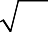  4 4  x = ± 17 + 7  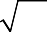  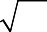  4 4  So x = 7 − 17 or x = 7 + 17  4 4 4 4 | - Rearrange the equation to work out  x. First, add 17 to both sides.  8  - Divide both sides by 2.  - Square root both sides. Remember that the square root of a value gives two answers.  - Add 7 to both sides.  4  - Write down both the solutions.

Practice

3 Solve by completing the square.
a x² – 4x – 3 = 0 | b | x² – 10x + 4 = 0
c x² + 8x – 5 = 0 | d | x² – 2x – 6 = 0
e 2x² + 8x – 5 = 0 | f | 5x² + 3x – 4 = 0
- Solve by completing the square.
Hint
Get all terms onto one side of the equation.
a (x – 4)(x + 2) = 5
b 2x² + 6x – 7 = 0
c x² – 5x + 3 = 0

Solving quadratic equations by using the formula
A LEVEL LINKS
Scheme of work: 1b. Quadratic functions – factorising, solving, graphs and the discriminants

Key points
  - Any quadratic equation of the form ax² + bx + c = 0 can be solved using the formula
−b ± b² − 4ac
x =
2a
  - If b² – 4ac is negative then the quadratic equation does not have any real solutions.
  - It is useful to write down the formula before substituting the values for a, b and c.

Examples
Example 7 Solve x² + 6x + 4 = 0. Give your solutions in surd form.

a = 1, b = 6, c = 4  −b ± b² − 4ac  x =  2a  −6 ± 6² − 4(1)(4)  x =  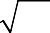  2(1)  x = −6 ± 20  2  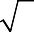  x = −6 ± 2 5  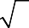  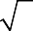  2  x = −3 ± 5  So x = −3 − 5 or x = 5 − 3 | - Identify a, b and c and write down the formula.  Remember that −b ± b² − 4ac is all over 2a, not just part of it.  - Substitute a = 1, b = 6, c = 4 into the formula.  - Simplify. The denominator is 2, but this is only because a = 1. The denominator will not always be 2.  - Simplify 20 .  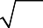  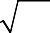  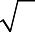  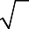  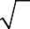  20 = 4 × 5 = 4 × 5 = 2 5  - Simplify by dividing numerator and denominator by 2.  - Write down both the solutions.

Example 8 Solve 3x² − 7x − 2 = 0. Give your solutions in surd form.

a = 3, b = −7, c = −2  −b ± b² − 4ac  x =  2a  −(−7) ± (−7)² − 4(3)(−2)  x =  2(3)  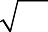  x = 7 ± 73  6  So x = 7 − 73 or x = 7 + 73  6 6 | - Identify a, b and c, making sure you get the signs right and write down the formula.  Remember that −b ± b² − 4ac is all over 2a, not just part of it.  - Substitute a = 3, b = −7, c = −2 into the formula.  - Simplify. The denominator is 6 when a = 3. A common mistake is to always write a denominator of 2.  - Write down both the solutions.

Practice
- Solve, giving your solutions in surd form.
a 3x² + 6x + 2 = 0 b 2x² – 4x – 7 = 0

- Solve the equation x² – 7x + 2 = 0
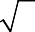
Give your solutions in the form a ±
c

b , where a, b and c are integers.

- Solve 10x² + 3x + 3 = 5
Hint
Get all terms onto one side of the equation.
Give your solution in surd form.

Extend
- Choose an appropriate method to solve each quadratic equation, giving your answer in surd form when necessary.
a 4x(x – 1) = 3x – 2
b 10 = (x + 1)²
c x(3x – 1) = 10

Answers

1 a | x = 0 or x = | − 2  3 | b | x = 0 or x = | 3  4
c | x = –5 or x = –2 |  | d | x = 2 or x = 3
e | x = –1 or x = 4 |  | f | x = –5 or x = 2
g | x = 4 or x = 6 |  | h | x = –6 or x = 6
i | x = –7 or x = 4 |  | j | x = 3

k x = − 1 2
or x = 4 l x = − 2
3
or x = 5

2 | a | x = –2 or x = 5 | b | x = –1 or x = 3
 | c | x = –8 or x = 3 | d | x = –6 or x = 7
 | e | x = –5 or x = 5 | f | x = –4 or x = 7

- x = –3 or x = 2 1
2
- x = − 1 3
or x = 2

3 a x = 2 +
7
c x = –4 +

e x = –2 +
or x = 2 –
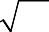
or x = –4 – or x = –2 –
7
21
6.5
b x = 5 +
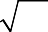
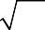
d x = 1 +
21
21
7
−3 + 89

f x =
6.5
10
or x = 5 – or x = 1 –
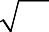
or x =
21
7
−3 − 89
10

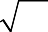
4 a x = 1 +
14

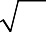
- x =
5 + 13
2

or x = 1 – or x =

b x =
14
−3 + 23
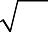
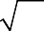
2
5 − 13
2

or x =
−3 − 23
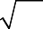
2

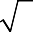
- a x = –1 + 3
3
or x = –1 – 3
3
b x = 1 + 3 2
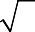
2
or x = 1 – 3 2
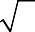
2

- x =

- x =
or x =

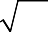
or x =
7 + 41
2
7 − 41
2
−3 + 89
−3 − 89
20 20

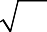
- a x =
7 + 17
8

b x = –1 +
c x = –1 2
3
or x =

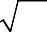
or x = –1 – or x = 2
7 − 17
8
10
10

Sketching quadratic graphs
A LEVEL LINKS
Scheme of work: 1b. Quadratic functions – factorising, solving, graphs and the discriminants

Key points
- The graph of the quadratic function
y = ax² + bx + c, where a ≠ 0, is a curve called a parabola.
- Parabolas have a line of symmetry and a shape as shown.

for a > 0 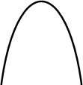 for a < 0

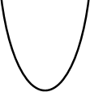
- To sketch the graph of a function, find the points where the graph intersects the axes.
- To find where the curve intersects the y-axis substitute x = 0 into the function.
- To find where the curve intersects the x-axis substitute y = 0 into the function.
- At the turning points of a graph the gradient of the curve is 0 and any tangents to the curve at these points are horizontal.
- To find the coordinates of the maximum or minimum point (turning points) of a quadratic curve (parabola) you can use the completed square form of the function.

Examples
Example 1 Sketch the graph of y = x².

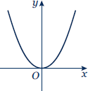 | The graph of y = x² is a parabola. When x = 0, y = 0.  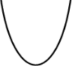  a = 1 which is greater than zero, so the graph has the shape:
Example 2 Sketch the graph of y = x² − x − 6.

When x = 0, y = 0² − 0 − 6 = −6  So the graph intersects the y-axis at (0, −6)  When y = 0, x² − x − 6 = 0 (x + 2)(x − 3) = 0  x = −2 or x = 3  So,  the graph intersects the x-axis at (−2, 0) and (3, 0) | 1 Find where the graph intersects the  y-axis by substituting x = 0.  - Find where the graph intersects the  x-axis by substituting y = 0.  - Solve the equation by factorising.  - Solve (x + 2) = 0 and (x − 3) = 0.  - a = 1 which is greater than zero, so the graph has the shape:  (continued on next page)

⎛ 1 ⎞² 1  x² − x − 6 = ⎜ x − ⎟ − − 6  ⎝ 2 ⎠ 4  ⎛ 1 ⎞² 25  = ⎜ x − 2 ⎟ − 4  ⎝ ⎠  ⎛ 1 ⎞² 1  When ⎜ x − 2 ⎟ = 0 , x = 2 and  ⎝ ⎠  y = − 25 , so the turning point is at the  4  point ⎛ 1 , − 25 ⎞  ⎜ 2 4 ⎟  ⎝ ⎠  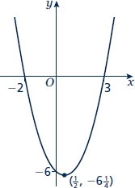 | - To find the turning point, complete the square.  - The turning point is the minimum value for this expression and occurs when the term in the bracket is equal to zero.

Practice
- Sketch the graph of y = −x².

- Sketch each graph, labelling where the curve crosses the axes.
a y = (x + 2)(x − 1) b y = x(x − 3) c y = (x + 1)(x + 5)

- Sketch each graph, labelling where the curve crosses the axes.
a y = x² − x − 6 b y = x² − 5x + 4 c y = x² – 4
- y = x² + 4x e y = 9 − x² f y = x² + 2x − 3

- Sketch the graph of y = 2x² + 5x − 3, labelling where the curve crosses the axes.

Extend
- Sketch each graph. Label where the curve crosses the axes and write down the coordinates of the turning point.
a y = x² − 5x + 6 b y = −x² + 7x − 12 c y = −x² + 4x

- Sketch the graph of y = x² + 2x + 1. Label where the curve crosses the axes and write down the equation of the line of symmetry.

Answers
1
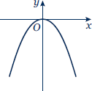
- a b c
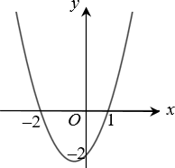
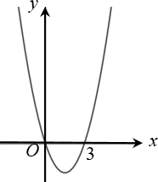
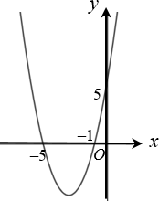

- a b c
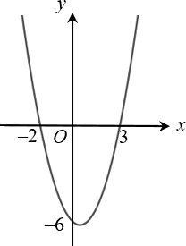
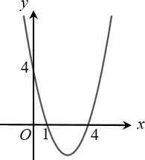
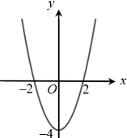

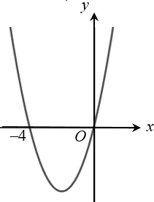
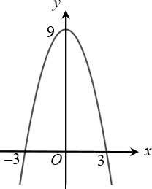
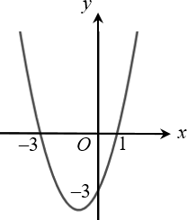
d e f

4
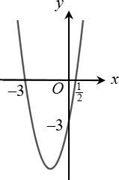

- a b c
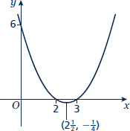
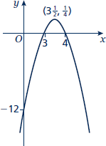
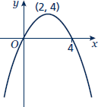

6
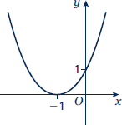
Line of symmetry at x = −1.

Solving linear simultaneous equations using the elimination method
A LEVEL LINKS
Scheme of work: 1c. Equations – quadratic/linear simultaneous

Key points
  - Two equations are simultaneous when they are both true at the same time.
  - Solving simultaneous linear equations in two unknowns involves finding the value of each unknown which works for both equations.
  - Make sure that the coefficient of one of the unknowns is the same in both equations.
  - Eliminate this equal unknown by either subtracting or adding the two equations.

Examples
Example 1 Solve the simultaneous equations 3x + y = 5 and x + y = 1

3x + y = 5  – x + y = 1 2x = 4  So x = 2  Using x + y = 1  2 + y = 1  So y = −1  Check:  equation 1: 3 × 2 + (−1) = 5 YES  equation 2: 2 + (−1) = 1 YES | - Subtract the second equation from the first equation to eliminate the y term.  - To find the value of y, substitute x = 2 into one of the original equations.  - Substitute the values of x and y into both equations to check your answers.
Example 2 Solve x + 2y = 13 and 5x − 2y = 5 simultaneously.

x + 2y = 13  + 5x − 2y = 5 6x = 18  So x = 3  Using x + 2y = 13  3 + 2y = 13  So y = 5  Check:  equation 1: 3 + 2 × 5 = 13 YES  equation 2: 5 × 3 − 2 × 5 = 5 YES | - Add the two equations together to eliminate the y term.  - To find the value of y, substitute x = 3 into one of the original equations.  - Substitute the values of x and y into both equations to check your answers.

Example 3 Solve 2x + 3y = 2 and 5x + 4y = 12 simultaneously.

(2x + 3y = 2) × 4 → 8x + 12y = 8 (5x + 4y = 12) × 3 → 15x + 12y = 36  7x = 28  So x = 4  Using 2x + 3y = 2  2 × 4 + 3y = 2  So y = −2  Check:  equation 1: 2 × 4 + 3 × (−2) = 2 YES  equation 2: 5 × 4 + 4 × (−2) = 12 YES | - Multiply the first equation by 4 and the second equation by 3 to make the coefficient of y the same for both equations. Then subtract the first equation from the second equation to eliminate the y term.  - To find the value of y, substitute x = 4 into one of the original equations.  - Substitute the values of x and y into both equations to check your answers.

Practice
Solve these simultaneous equations.

1 | 4x + y = 8  x + y = 5 | 2 | 3x + y = 7 3x + 2y = 5
3 | 4x + y = 3 3x – y = 11 | 4 | 3x + 4y = 7  x – 4y = 5
5 | 2x + y = 11  x – 3y = 9 | 6 | 2x + 3y = 11  3x + 2y = 4

Solving linear simultaneous equations using the substitution method
A LEVEL LINKS
Scheme of work: 1c. Equations – quadratic/linear simultaneous
Textbook: Pure Year 1, 3.1 Linear simultaneous equations

Key points
  - The subsitution method is the method most commonly used for A level. This is because it is the method used to solve linear and quadratic simultaneous equations.

Examples
Example 4 Solve the simultaneous equations y = 2x + 1 and 5x + 3y = 14

5x + 3(2x + 1) = 14  5x + 6x + 3 = 14  11x + 3 = 14  11x = 11  So x = 1  Using y = 2x + 1  y = 2 × 1 + 1  So y = 3  Check:  equation 1: 3 = 2 × 1 + 1 YES  equation 2: 5 × 1 + 3 × 3 = 14 YES | - Substitute 2x + 1 for y into the second equation.  - Expand the brackets and simplify.  - Work out the value of x.  - To find the value of y, substitute x = 1 into one of the original equations.  - Substitute the values of x and y into both equations to check your answers.
Example 5 Solve 2x − y = 16 and 4x + 3y = −3 simultaneously.

y = 2x − 16  4x + 3(2x − 16) = −3  4x + 6x − 48 = −3  10x − 48 = −3  10x = 45  So x = 4 ¹  2  Using y = 2x − 16  y = 2 × 4 ¹ − 16  2  So y = −7  Check:  equation 1: 2 × 4 ¹ – (–7) = 16 YES  2  equation 2: 4 × 4 ¹ + 3 × (−7) = −3 YES  2 | - Rearrange the first equation.  - Substitute 2x − 16 for y into the second equation.  - Expand the brackets and simplify.  - Work out the value of x.  - To find the value of y, substitute  x = 4 ¹ into one of the original  2  equations.  - Substitute the values of x and y into both equations to check your answers.

Practice
Solve these simultaneous equations.

7 | y = x – 4  2x + 5y = 43 | 8 | y = 2x – 3 5x – 3y = 11
9 | 2y = 4x + 5  9x + 5y = 22 | 10 | 2x = y – 2  8x – 5y = –11
11 | 3x + 4y = 8  2x – y = –13 | 12 | 3y = 4x – 7  2y = 3x – 4
13 | 3x = y – 1 2y – 2x = 3 | 14 | 3x + 2y + 1 = 0  4y = 8 – x

Extend
15 Solve the simultaneous equations 3x + 5y − 20 = 0 and 2(x + y) = 3( y − x) .
4

Answers
1 x = 1, y = 4

2 x = 3, y = –2

3 x = 2, y = –5

- x = 3, y = – ¹
2

- x = 6, y = –1

- x = –2, y = 5

- x = 9, y = 5

- x = –2, y = –7

- x = 1 , y = 3 1
2 2

- x = ¹ , y = 3
2

- x = –4, y = 5

- x = –2, y = –5

- x = 1 , y = 1 3
4 4

- x = –2, y = 2 ¹
2

- x = –2 1 , y = 5 1
2 2

Solving linear and quadratic simultaneous equations
A LEVEL LINKS
Scheme of work: 1c. Equations – quadratic/linear simultaneous

Key points
  - Make one of the unknowns the subject of the linear equation (rearranging where necessary).
  - Use the linear equation to substitute into the quadratic equation.
  - There are usually two pairs of solutions.

Examples
Example 1 Solve the simultaneous equations y = x + 1 and x² + y² = 13

x² + (x + 1)² = 13  x² + x² + x + x + 1 = 13 2x² + 2x + 1 = 13  2x² + 2x − 12 = 0 (2x − 4)(x + 3) = 0  So x = 2 or x = −3  Using y = x + 1  When x = 2, y = 2 + 1 = 3  When x = −3, y = −3 + 1 = −2  So the solutions are  x = 2, y = 3 and x = −3, y = −2  Check:  equation 1: 3 = 2 + 1 YES  and −2 = −3 + 1 YES  equation 2: 2² + 3² = 13 YES  and (−3)² + (−2)² = 13 YES | - Substitute x + 1 for y into the second equation.  - Expand the brackets and simplify.  - Factorise the quadratic equation.  - Work out the values of x.  - To find the value of y, substitute both values of x into one of the original equations.  - Substitute both pairs of values of x and y into both equations to check your answers.

Example 2 Solve 2x + 3y = 5 and 2y² + xy = 12 simultaneously.

x = 5 − 3y  2  2 y² + ⎛ 5 − 3y ⎞ y = 12  ⎜ 2 ⎟  ⎝ ⎠  ₂ 5 y − 3y²  2 y + = 12  2  4 y² + 5 y − 3y² = 24  y² + 5 y − 24 = 0  (y + 8)(y − 3) = 0  So y = −8 or y = 3  Using 2x + 3y = 5  When y = −8, 2x + 3 × (−8) = 5, x = 14.5  When y = 3, 2x + 3 × 3 = 5, x = −2  So the solutions are  x = 14.5, y = −8 and x = −2, y = 3  Check:  equation 1: 2 × 14.5 + 3 × (−8) = 5 YES  and 2 × (−2) + 3 × 3 = 5 YES  equation 2: 2×(−8)² + 14.5×(−8) = 12 YES  and 2 × (3)² + (−2) × 3 = 12 YES | - Rearrange the first equation.  - Substitute 5 − 3y for x into the  2  second equation. Notice how it is easier to substitute for x than for y.  - Expand the brackets and simplify.  - Factorise the quadratic equation.  - Work out the values of y.  - To find the value of x, substitute both values of y into one of the original equations.  - Substitute both pairs of values of x and y into both equations to check your answers.

Practice
Solve these simultaneous equations.

1 | y = 2x + 1  x² + y² = 10 | 2 | y = 6 − x  x² + y² = 20
3 | y = x – 3  x² + y² = 5 | 4 | y = 9 − 2x x² + y² = 17
5 | y = 3x – 5  y = x² − 2x + 1 | 6 | y = x − 5  y = x² − 5x − 12
7 | y = x + 5  x² + y² = 25 | 8 | y = 2x – 1  x² + xy = 24
9 | y = 2x  y² – xy = 8 | 10 | 2x + y = 11  xy = 15
Extend
11 x – y = 1  x² + y² = 3 |  | 12 | y – x = 2  x² + xy = 3

Answers
1 x = 1, y = 3
x = − 9 , y = − 13
5 5

2 x = 2, y = 4
x = 4, y = 2

3 x = 1, y = −2
x = 2, y = –1

4 x = 4, y = 1
x = 16 , y = 13
5 5

5 x = 3, y = 4
x = 2, y = 1

- x = 7, y = 2
x = −1, y = −6

- x = 0, y = 5
x = –5, y = 0

- x = − 8 , y = − 19
3 3
x = 3, y = 5

- x = –2, y = –4
x = 2, y = 4

- x = 5 , y = 6
2
x = 3, y = 5

- x = 1 +
2
x = 1 −
2
5 , y =
2
−1 + 5
5 , y =
−1 − 5
2

- x =

x =

2

2
, y = 3 + 7
2
−1 + 7
, y = 3 − 7
−1 − 7
2

Solving simultaneous equations graphically
A LEVEL LINKS
Scheme of work: 1c. Equations – quadratic/linear simultaneous

Key points
- You can solve any pair of simultaneous equations by drawing the graph of both equations and finding the point/points of intersection.

Examples
Example 1 Solve the simultaneous equations y = 5x + 2 and x + y = 5 graphically.

y = 5 – x  y = 5 – x has gradient –1 and y-intercept 5.  y = 5x + 2 has gradient 5 and y-intercept 2.  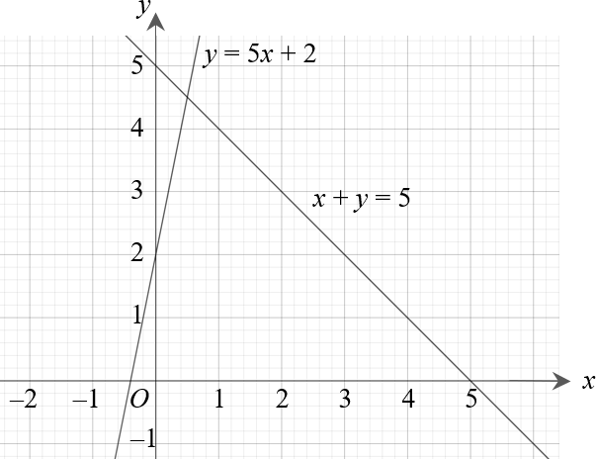  Lines intersect at  x = 0.5, y = 4.5  Check:  First equation y = 5x + 2:  4.5 = 5 × 0.5 + 2 YES  Second equation x + y = 5:  0.5 + 4.5 = 5 YES | - Rearrange the equation x + y = 5 to make y the subject.  - Plot both graphs on the same grid using the gradients and  y-intercepts.  - The solutions of the simultaneous equations are the point of intersection.  - Check your solutions by substituting the values into both equations.

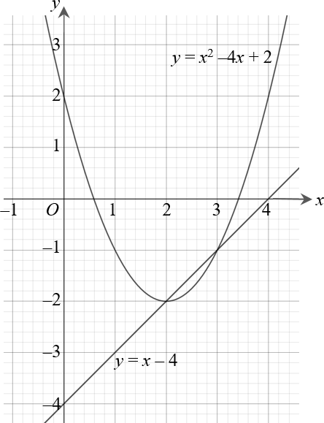
Example 2 Solve the simultaneous equations y = x − 4 and y = x² − 4x + 2 graphically.

The line and curve intersect at
x = 3, y = −1 and x = 2, y = −2
Check:
First equation y = x − 4:
−1 = 3 − 4 YES
−2 = 2 − 4 YES
Second equation y = x² − 4x + 2:
−1 = 3² − 4 × 3 + 2 YES
−2 = 2² − 4 × 2 + 2 YES
- The solutions of the simultaneous equations are the points of intersection.
- Check your solutions by substituting the values into both equations.
- Plot the graph.

- Plot the linear graph on the same grid using the gradient and
y-intercept.
y = x – 4 has gradient 1 and
y-intercept –4.
1 Construct a table of values and calculate the points for the quadratic equation.

x | 0 | 1 | 2 | 3 | 4
y | 2 | –1 | –2 | –1 | 2

Practice
- Solve these pairs of simultaneous equations graphically.
  - y = 3x − 1 and y = x + 3
  - y = x − 5 and y = 7 − 5x
  - y = 3x + 4 and y = 2 − x

- Solve these pairs of simultaneous equations graphically.
Hint
Rearrange the equation to make y the subject.
  - x + y = 0 and y = 2x + 6
  - 4x + 2y = 3 and y = 3x − 1
  - 2x + y + 4 = 0 and 2y = 3x − 1

- Solve these pairs of simultaneous equations graphically.
  - y = x − 1 and y = x² − 4x + 3
  - y = 1 − 3x and y = x² − 3x − 3
  - y = 3 − x and y = x² + 2x + 5

- Solve the simultaneous equations x + y = 1 and x² + y² = 25 graphically.

Extend
- a Solve the simultaneous equations 2x + y = 3 and x² + y = 4
- graphically
- algebraically to 2 decimal places.
- Which method gives the more accurate solutions? Explain your answer.

Answers
1 a x = 2, y = 5
b x = 2, y = −3
- x = −0.5, y = 2.5

2 a x = −2, y = 2
b x = 0.5, y = 0.5
c x = −1, y = −2

3 a x = 1, y = 0 and x = 4, y = 3
b x = −2, y = 7 and x = 2, y = −5
c x = −2, y = 5 and x = −1, y = 4

4 x = −3, y = 4 and x = 4, y = −3

5 a i x = 2.5, y = −2 and x = −0.5, y = 4
ii x = 2.41, y = −1.83 and x = −0.41, y = 3.83
b Solving algebraically gives the more accurate solutions as the solutions from the graph are only estimates, based on the accuracy of your graph.

Linear inequalities
A LEVEL LINKS
Scheme of work: 1d. Inequalities – linear and quadratic (including graphical solutions)

Key points
- Solving linear inequalities uses similar methods to those for solving linear equations.
- When you multiply or divide an inequality by a negative number you need to reverse the inequality sign, e.g. < becomes >.

Examples
Example 1 Solve −8 ≤ 4x < 16

−8 ≤ 4x < 16  −2 ≤ x < 4 | Divide all three terms by 4.

Example 2 Solve 4 ≤ 5x < 10

4 ≤ 5x < 10  ⁴ ≤ x < 2  5 | Divide all three terms by 5.

Example 3 Solve 2x − 5 < 7

2x − 5 < 7  2x < 12  x < 6 | - Add 5 to both sides.  - Divide both sides by 2.

Example 4 Solve 2 − 5x ≥ −8

2 − 5x ≥ −8  −5x ≥ −10  x ≤ 2 | - Subtract 2 from both sides.  - Divide both sides by −5. Remember to reverse the inequality when dividing by a negative number.

Example 5 Solve 4(x − 2) > 3(9 − x)

4(x − 2) > 3(9 − x)  4x − 8 > 27 − 3x  7x − 8 > 27  7x > 35  x > 5 | - Expand the brackets.  - Add 3x to both sides.  - Add 8 to both sides.  - Divide both sides by 7.

Practice
- Solve these inequalities.
a 4x > 16 b 5x – 7 ≤ 3 c 1 ≥ 3x + 4

- 5 – 2x < 12 e
x ≥ 5
2
f 8 < 3 – x
3

- Solve these inequalities.
a x < −4 |  | b | 10 ≥ 2x + 3 | c | 7 – 3x > –5
3 | Solve  a 2 – 4x ≥ 18 | b | 3 ≤ 7x + 10 < 45 | c | 6 – 2x ≥ 4
 | d 4x + 17 < 2 – x | e | 4 – 5x < –3x | f | –4x ≥ 24

5

- Solve these inequalities.
a 3t + 1 < t + 6 b 2(3n – 1) ≥ n + 5

- Solve.
a 3(2 – x) > 2(4 – x) + 4 b 5(4 – x) > 3(5 – x) + 2

Extend
- Find the set of values of x for which 2x + 1 > 11 and 4x – 2 > 16 – 2x.

Answers

2
1 | a d | x > 4  x > – 7 |  | b e | x ≤ 2  x ≥ 10 |  | c f | x ≤ –1  x < –15
2 | a | x < –20 |  | b | x ≤ 3.5 |  | c | x < 4
3 | a | x ≤ –4 |  | b | –1 ≤ x < 5 |  | c | x ≤ 1
 | d | x < –3 |  | e | x > 2 |  | f | x ≤ –6
4 | a | t < | 5  2 | b | n ≥ | 7  5
5 | a | x < –6 |  | b | x < | 3  2
6 | x > 5 (which also satisfies x > 3)

Quadratic inequalities
A LEVEL LINKS
Scheme of work: 1d. Inequalities – linear and quadratic (including graphical solutions)

Key points
  - First replace the inequality sign by = and solve the quadratic equation.
  - Sketch the graph of the quadratic function.
  - Use the graph to find the values which satisfy the quadratic inequality.

Examples
Example 1 Find the set of values of x which satisfy x² + 5x + 6 > 0

x² + 5x + 6 = 0 (x + 3)(x + 2) = 0  x = −3 or x = −2  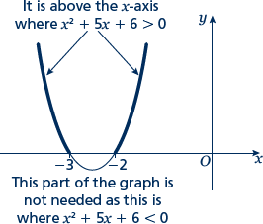  x < −3 or x > −2 | - Solve the quadratic equation by factorising.  - Sketch the graph of  y = (x + 3)(x + 2)  - Identify on the graph where  x² + 5x + 6 > 0, i.e. where y > 0  - Write down the values which satisfy the inequality x² + 5x + 6 > 0

Example 2 Find the set of values of x which satisfy x² − 5x ≤ 0

x² − 5x = 0  x(x − 5) = 0  x = 0 or x = 5  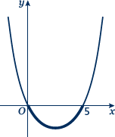  0 ≤ x ≤ 5 | - Solve the quadratic equation by factorising.  - Sketch the graph of y = x(x − 5)  - Identify on the graph where  x² − 5x ≤ 0, i.e. where y ≤ 0  - Write down the values which satisfy the inequality x² − 5x ≤ 0

Example 3 Find the set of values of x which satisfy −x² − 3x + 10 ≥ 0

−x² − 3x + 10 = 0 (−x + 2)(x + 5) = 0  x = 2 or x = −5  y  –5 O 2 x  −5 ≤ x ≤ 2 | - Solve the quadratic equation by factorising.  - Sketch the graph of  y = (−x + 2)(x + 5) = 0  - Identify on the graph where  −x² − 3x + 10 ≥ 0, i.e. where y ≥ 0  3 Write down the values which satisfy the inequality −x² − 3x + 10 ≥ 0

Practice
- Find the set of values of x for which (x + 7)(x – 4) ≤ 0

- Find the set of values of x for which x² – 4x – 12 ≥ 0

- Find the set of values of x for which 2x² –7x + 3 < 0

- Find the set of values of x for which 4x² + 4x – 3 > 0

- Find the set of values of x for which 12 + x – x² ≥ 0

Extend
Find the set of values which satisfy the following inequalities.

- x² + x ≤ 6

- x(2x – 9) < –10

- 6x² ≥ 15 + x

Answers
1 –7 ≤ x ≤ 4

2 x ≤ –2 or x ≥ 6

- 1 < x < 3
2

- x < − 3
2
or x > 1
2

- –3 ≤ x ≤ 4

- –3 ≤ x ≤ 2

- 2 < x < 2 1
2

- x ≤− 3
2
or x ≥ 5
3

Sketching cubic and reciprocal graphs
A LEVEL LINKS
Scheme of work: 1e. Graphs – cubic, quartic and reciprocal

Key points
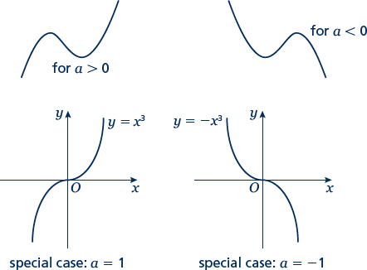
  - The graph of a cubic function, which can be written in the form y = ax³ + bx² + cx + d, where a ≠ 0, has one of the shapes shown here.

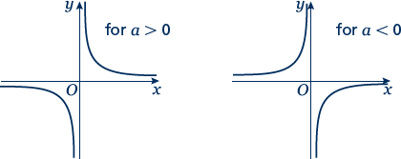
  - The graph of a reciprocal

function of the form
y = a
x
has

one of the shapes shown here.

  - To sketch the graph of a function, find the points where the graph intersects the axes.
  - To find where the curve intersects the y-axis substitute x = 0 into the function.
  - To find where the curve intersects the x-axis substitute y = 0 into the function.
  - Where appropriate, mark and label the asymptotes on the graph.
  - Asymptotes are lines (usually horizontal or vertical) which the curve gets closer to but never touches or crosses. Asymptotes usually occur with reciprocal functions. For example, the

asymptotes for the graph of
y = a
x
are the two axes (the lines y = 0 and x = 0).

  - At the turning points of a graph the gradient of the curve is 0 and any tangents to the curve at these points are horizontal.
  - A double root is when two of the solutions are equal. For example (x – 3)²(x + 2) has a double root at x = 3.
  - When there is a double root, this is one of the turning points of a cubic function.

Examples
Example 1 Sketch the graph of y = (x − 3)(x − 1)(x + 2)

To sketch a cubic curve find intersects with both axes and use the key points above for the correct shape.
When x = 0, y = (0 − 3)(0 − 1)(0 + 2)  = (−3) × (−1) × 2 = 6  The graph intersects the y-axis at (0, 6)  When y = 0, (x − 3)(x − 1)(x + 2) = 0  So x = 3, x = 1 or x = −2  The graph intersects the x-axis at (−2, 0), (1, 0) and (3, 0)  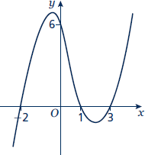 | - Find where the graph intersects the axes by substituting x = 0 and y = 0. Make sure you get the coordinates the right way around, (x, y).  - Solve the equation by solving  x − 3 = 0, x − 1 = 0 and x + 2 = 0  - Sketch the graph.  a = 1 > 0 so the graph has the shape:  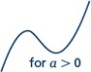
Example 2 Sketch the graph of y = (x + 2)²(x − 1)

To sketch a cubic curve find intersects with both axes and use the key points above for the correct shape.
When x = 0, y = (0 + 2)²(0 − 1)  = 2² × (−1) = −4  The graph intersects the y-axis at (0, −4)  When y = 0, (x + 2)²(x − 1) = 0  So x = −2 or x =1  (−2, 0) is a turning point as x = −2 is a double root.  The graph crosses the x-axis at (1, 0)  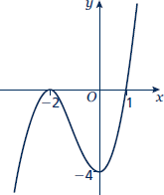 | - Find where the graph intersects the axes by substituting x = 0 and y = 0.  - Solve the equation by solving  x + 2 = 0 and x − 1 = 0  - a = 1 > 0 so the graph has the shape:

Practice
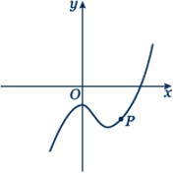
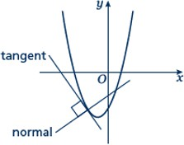
1 Here are six equations.
Hint
Find where each of the cubic equations cross the y-axis.

A y = |  | 5  x | B | y = x² + 3x – 10 | C | y = x³ + 3x²
D | y = 1 – 3x² – x³ |  | E | y = x³ – 3x² – 1 | F | x + y = 5
Here are six graphs.  i |  |  | ii |  | iii
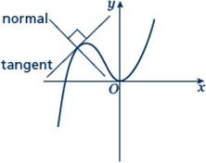

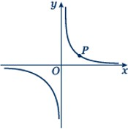
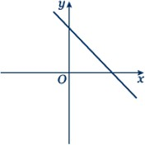
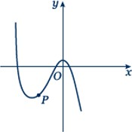
iv v vi

- Match each graph to its equation.
- Copy the graphs ii, iv and vi and draw the tangent and normal each at point P.

Sketch the following graphs

2 | y = 2x³ | 3 | y = x(x – 2)(x + 2)
4 | y = (x + 1)(x + 4)(x – 3) | 5 | y = (x + 1)(x – 2)(1 – x)
6 | y = (x – 3)²(x + 1) | 7 | y = (x – 1)²(x – 2)

8 y = 3
x
9 y = − 2
x
Hint: Look at the shape of y = a
x
in the second key point.
1

Extend
- Sketch the graph of
1

y = x + 2

- Sketch the graph of

y = x − 1

Answers
- a i – C
  - – E
  - – B
  - – A
  - – F
  - – D
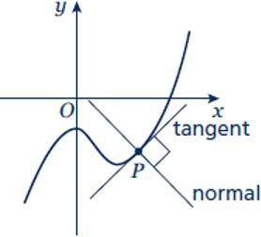
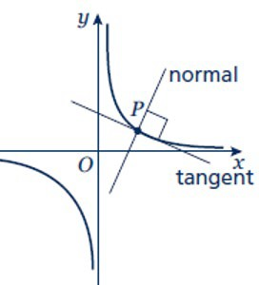
b ii iv

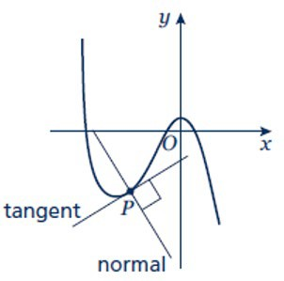
vi

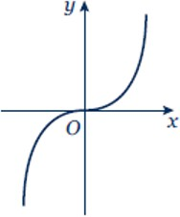
2 3
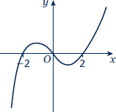
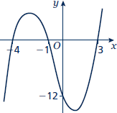
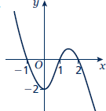
4 5

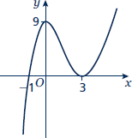
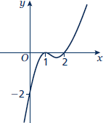
6 7

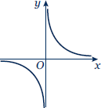
8 9
y
O
x

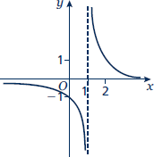
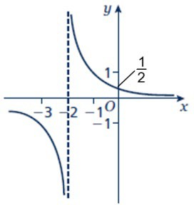
10 11

Translating graphs
A LEVEL LINKS
Scheme of work: 1f. Transformations – transforming graphs – f(x) notation

Key points
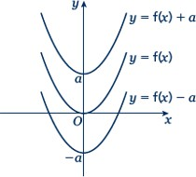
- The transformation y = f(x) ± a is a translation of y = f(x) parallel to the y-axis; it is a vertical translation.

As shown on the graph,
  - y = f(x) + a translates y = f(x) up
  - y = f(x) – a translates y = f(x) down.

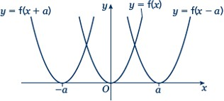
- The transformation y = f(x ± a) is a translation of y = f(x) parallel to the x-axis; it is a horizontal translation.

As shown on the graph,
  - y = f(x + a) translates y = f(x) to the left
  - y = f(x – a) translates y = f(x) to the right.

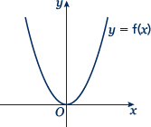
Examples
Example 1 The graph shows the function y = f(x).
Sketch the graph of y = f(x) + 2.

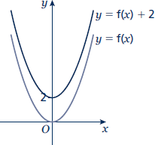 | For the function y = f(x) + 2 translate the function y = f(x) 2 units up.

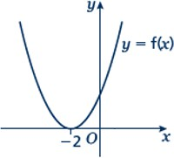
Example 2 The graph shows the function y = f(x).
Sketch the graph of y = f(x − 3).

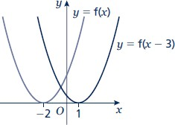 | For the function y = f(x − 3) translate the function y = f(x) 3 units right.

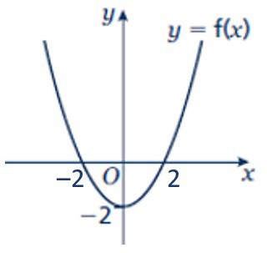
Practice
- The graph shows the function y = f(x).
Copy the graph and on the same axes sketch and label the graphs of y = f(x) + 4 and y = f(x + 2).

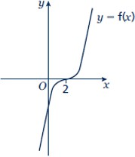
- The graph shows the function y = f(x).
Copy the graph and on the same axes sketch and label the graphs of y = f(x + 3) and y = f(x) – 3.

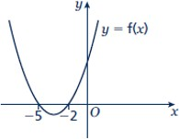
- The graph shows the function y = f(x).
Copy the graph and on the same axes sketch the graph of y = f(x – 5).

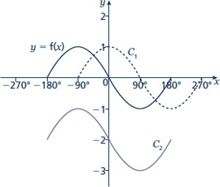
- The graph shows the function y = f(x) and two transformations of y = f(x), labelled C1 and C2. Write down the equations of the translated curves C1 and C2 in function form.

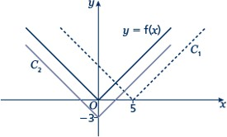
- The graph shows the function y = f(x) and two transformations of y = f(x), labelled C1 and C2. Write down the equations of the translated curves C1 and C2 in function form.

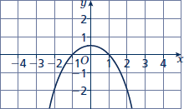
- The graph shows the function y = f(x).

  - Sketch the graph of y = f(x) + 2
  - Sketch the graph of y = f(x + 2)

Stretching graphs
A LEVEL LINKS
Scheme of work: 1f. Transformations – transforming graphs – f(x) notation
Textbook: Pure Year 1, 4.6 Stretching graphs

Key points

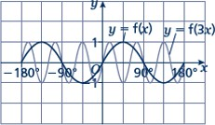
- The transformation y = f(ax) is a horizontal stretch of y = f(x) with scale factor ¹
a
parallel to the x-axis.

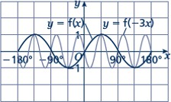
- The transformation y = f(–ax) is a horizontal stretch of y = f(x) with scale

factor ¹
a
parallel to the x-axis and then a

reflection in the y-axis.

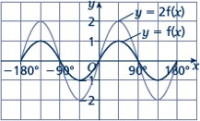
- The transformation y = af(x) is a vertical stretch of y = f(x) with scale factor a parallel to the y-axis.

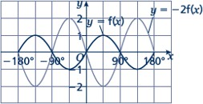
- The transformation y = –af(x) is a vertical stretch of y = f(x) with scale factor a parallel to the y-axis and then a reflection in the x-axis.

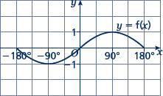
Examples
Example 3 The graph shows the function y = f(x).
Sketch and label the graphs of
y = 2f(x) and y = –f(x).
The function y = 2f(x) is a vertical stretch of y = f(x) with scale factor 2 parallel to the y-axis.
The function y = −f(x) is a reflection of y = f(x) in the x-axis.

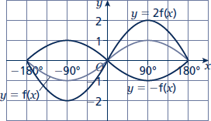

Example 4 The graph shows the function y = f(x).
Sketch and label the graphs of
y = f(2x) and y = f(–x).

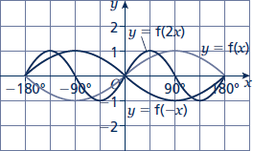
parallel to the x-axis.
The function y = f(−x) is a reflection of y = f(x) in the y-axis.
2
stretch of y = f(x) with scale factor ¹
The function y = f(2x) is a horizontal

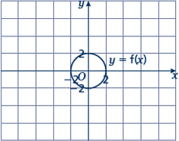
Practice
- The graph shows the function y = f(x).
  - Copy the graph and on the same axes sketch and label the graph of y = 3f(x).
  - Make another copy of the graph and on the same axes sketch and label the graph of y = f(2x).

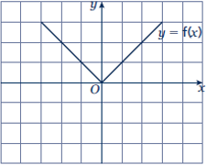
- The graph shows the function y = f(x). Copy the graph and on the same axes sketch and label the graphs of
y = –2f(x) and y = f(3x).

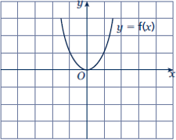
- The graph shows the function y = f(x). Copy the graph and, on the same axes, sketch and label the graphs of
y = –f(x) and y = f ( 1 x) .
2

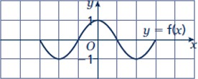
- The graph shows the function y = f(x). Copy the graph and, on the same axes, sketch the graph of y = –f(2x).

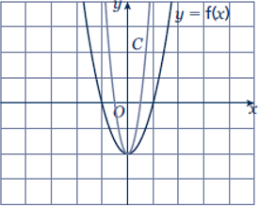
- The graph shows the function y = f(x) and a transformation, labelled C.
Write down the equation of the translated curve C in function form.

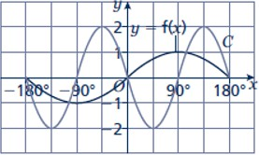
- The graph shows the function y = f(x) and a transformation labelled C.
Write down the equation of the translated curve C in function form.

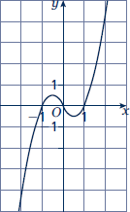
- The graph shows the function y = f(x).
  - Sketch the graph of y = −f(x).
  - Sketch the graph of y = 2f(x).

Extend

- a Sketch and label the graph of y = f(x), where f(x) = (x – 1)(x + 1).
b On the same axes, sketch and label the graphs of y = f(x) – 2 and y = f(x + 2).

- a Sketch and label the graph of y = f(x), where f(x) = –(x + 1)(x – 2).
- On the same axes, sketch and label the graph of y = f (− 1 x) .
2

Answers
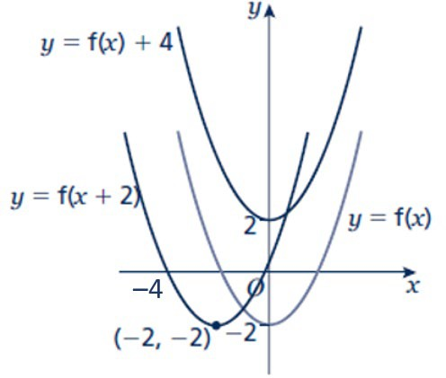
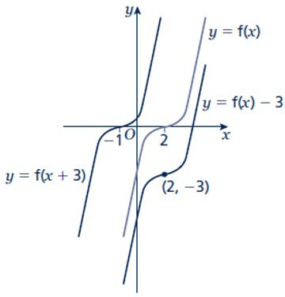
1 2

3
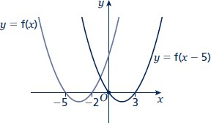

4 C1: y = f(x – 90°)
C2: y = f(x) – 2

5 C1: y = f(x – 5)
C2: y = f(x) – 3

6 a b
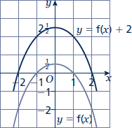
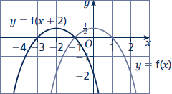

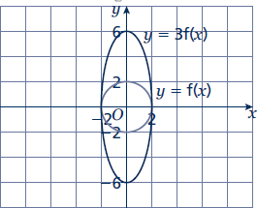
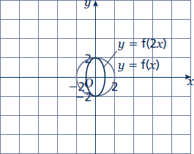
7 a b

8 9
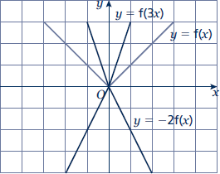
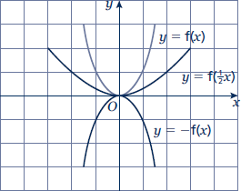

10
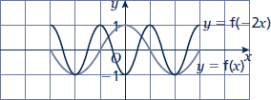

11 y = f(2x)

12 y = –2f(2x) or y = 2f(–2x)

13 a b
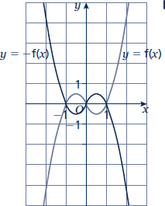
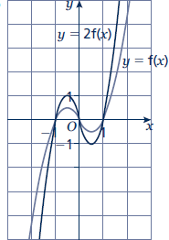

14
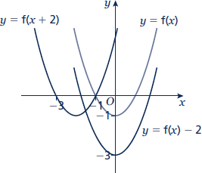

15
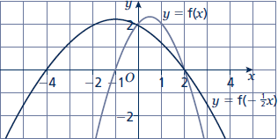

Straight line graphs
A LEVEL LINKS
Scheme of work: 2a. Straight-line graphs, parallel/perpendicular, length and area problems

Key points
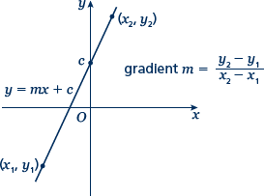
- A straight line has the equation y = mx + c, where m is the gradient and c is the y-intercept (where x = 0).
- The equation of a straight line can be written in the form
ax + by + c = 0, where a, b and c are integers.
- When given the coordinates (x1, y1) and (x2, y2) of two points on a line the gradient is calculated using the
formula m = y2 − y1
x2 − x1

Examples
Example 1 A straight line has gradient − 1
2

and y-intercept 3.

Write the equation of the line in the form ax + by + c = 0.

m = − 1 and c = 3  2  So y = − 1 x + 3  2  1 x + y – 3 = 0  2  x + 2y − 6 = 0 | - A straight line has equation  y = mx + c. Substitute the gradient and y-intercept given in the question into this equation.  - Rearrange the equation so all the terms are on one side and 0 is on the other side.  - Multiply both sides by 2 to eliminate the denominator.

Example 2 Find the gradient and the y-intercept of the line with the equation 3y − 2x + 4 = 0.

3y − 2x + 4 = 0  3y = 2x − 4  y = 2 x − 4  3 3  Gradient = m = 2  3  y-intercept = c = − 4  3 | - Make y the subject of the equation.  - Divide all the terms by three to get the equation in the form y = …  - In the form y = mx + c, the gradient is m and the y-intercept is c.

Example 3 Find the equation of the line which passes through the point (5, 13) and has gradient 3.

m = 3  y = 3x + c  13 = 3 × 5 + c  13 = 15 + c  c = −2  y = 3x − 2 | - Substitute the gradient given in the question into the equation of a straight line y = mx + c.  - Substitute the coordinates x = 5 and  y = 13 into the equation.  - Simplify and solve the equation.  - Substitute c = −2 into the equation  y = 3x + c

Example 4 Find the equation of the line passing through the points with coordinates (2, 4) and (8, 7).

x1 = 2 , x2 = 8 , y1 = 4 and y2 = 7  m = y2 − y1 = 7 − 4 = 3 = 1  x₂ − x₁ 8 − 2 6 2  y = 1 x + c  2  4 = 1 × 2 + c  2  c = 3  y = 1 x + 3  2 | - Substitute the coordinates into the  equation m = y2 − y1 to work out  x2 − x1  the gradient of the line.  - Substitute the gradient into the equation of a straight line  y = mx + c.  - Substitute the coordinates of either point into the equation.  - Simplify and solve the equation.  - Substitute c = 3 into the equation  y = 1 x + c  2

Practice
- Find the gradient and the y-intercept of the following equations.
a | y = 3x + 5 | b | y = − 1 x – 7  2
c  e | 2y = 4x – 3  2x – 3y – 7 = 0 | d  f | x + y = 5  5x + y – 4 = 0

Hint
Rearrange the equations to the form y = mx + c

- Copy and complete the table, giving the equation of the line in the form y = mx + c.

Gradient | y-intercept | Equation of the line
5 | 0
–3 | 2
4 | –7

- Find, in the form ax + by + c = 0 where a, b and c are integers, an equation for each of the lines with the following gradients and y-intercepts.
a gradient − 1 , y-intercept –7 b gradient 2, y-intercept 0
2
- gradient 2 , y-intercept 4 d gradient –1.2, y-intercept –2
3

- Write an equation for the line which passes though the point (2, 5) and has gradient 4.

- Write an equation for the line which passes through the point (6, 3) and has gradient − 2
3

- Write an equation for the line passing through each of the following pairs of points.

a | (4, 5), (10, 17) | b | (0, 6), (–4, 8)
c | (–1, –7), (5, 23) | d | (3, 10), (4, 7)

Extend
- The equation of a line is 2y + 3x – 6 = 0.
Write as much information as possible about this line.

Answers

1 a m = 3, c = 5 b m = − 1 , c = –7
2

c m = 2, c = − 3
2
e m = 2 , c = − 7 or –2 1
- m = –1, c = 5

f m = –5, c = 4

3 3 3

2

Gradient | y-intercept | Equation of the line
5 | 0 | y = 5x
–3 | 2 | y = –3x + 2
4 | –7 | y = 4x –7

3 | a | x + 2y + 14 = 0 | b | 2x – y = 0
 | c | 2x – 3y + 12 = 0 | d | 6x + 5y + 10 = 0

4 y = 4x – 3

5 y = − 2 x + 7
3

6 | a | y = 2x – 3 | b | y = − 1 x + 6  2
 | c | y = 5x –2 | d | y = –3x + 19

7 y = − 3 x + 3 , the gradient is − 3
and the y-intercept is 3.

2 2

The line intercepts the axes at (0, 3) and (2, 0).
Students may sketch the line or give coordinates that lie on the line such as ⎛1,
⎜
3 ⎞ or (4, −3) .
2
⎟

⎝ ⎠

Parallel and perpendicular lines
A LEVEL LINKS
Scheme of work: 2a. Straight-line graphs, parallel/perpendicular, length and area problems

Key points
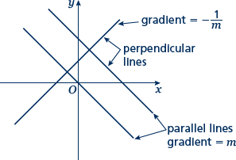
- When lines are parallel they have the same gradient.
- A line perpendicular to the line with equation
y = mx + c has gradient − 1 .
m

Examples
Example 1 Find the equation of the line parallel to y = 2x + 4 which passes through the point (4, 9).

y = 2x + 4  m = 2  y = 2x + c  9 = 2 × 4 + c  9 = 8 + c  c = 1  y = 2x + 1 | - As the lines are parallel they have the same gradient.  - Substitute m = 2 into the equation of a straight line y = mx + c.  - Substitute the coordinates into the equation y = 2x + c  - Simplify and solve the equation.  - Substitute c = 1 into the equation  y = 2x + c
Example 2 Find the equation of the line perpendicular to y = 2x − 3 which passes through the point (−2, 5).

y = 2x − 3  m = 2  − 1 = − 1  m 2  y = − 1 x + c  2  5 = − 1 × (−2) + c  2  5 = 1 + c  c = 4  y = − 1 x + 4 2 | - As the lines are perpendicular, the gradient of the perpendicular line  is − 1 .  m  - Substitute m = − 1 into y = mx + c.  2  - Substitute the coordinates (–2, 5)  into the equation y = − 1 x + c  2  - Simplify and solve the equation.  - Substitute c = 4 into y = − 1 x + c .  2

Example 3 A line passes through the points (0, 5) and (9, −1).
Find the equation of the line which is perpendicular to the line and passes through its midpoint.

x1 = 0 , x2 = 9 , y1 = 5 and y2 = −1  m = y2 − y1 = −1 − 5  x2 − x1 9 − 0  = −6 = − 2  9 3  − 1 = 3  m 2  y = 3 x + c  2  Midpoint = ⎛ 0 + 9 , 5 + (−1) ⎞ = ⎛ 9 , 2 ⎞  ⎜ 2 2 ⎟ ⎜ 2 ⎟  ⎝ ⎠ ⎝ ⎠  2 = 3 × 9 + c  2 2  c = − 19  4  y = 3 x − 19  2 4 | - Substitute the coordinates into the  equation m = y2 − y1 to work out  x2 − x1  the gradient of the line.  - As the lines are perpendicular, the gradient of the perpendicular line  is − 1 .  m  - Substitute the gradient into the equation y = mx + c.  - Work out the coordinates of the midpoint of the line.  - Substitute the coordinates of the midpoint into the equation.  - Simplify and solve the equation.  - Substitute c = − 19 into the equation  4  y = 3 x + c .  2

Practice
- Find the equation of the line parallel to each of the given lines and which passes through each of the given points.

a | y = 3x + 1 (3, 2) | b | y = 3 – 2x (1, 3)
c | 2x + 4y + 3 = 0 (6, –3) | d | 2y –3x + 2 = 0 (8, 20)

- Find the equation of the line perpendicular to y = 1 x – 3 which
Hint
If m = a then the negative
b
reciprocal − 1 = − b
m a
2
passes through the point (–5, 3).

- Find the equation of the line perpendicular to each of the given lines and which passes through each of the given points.
a y = 2x – 6 (4, 0) b y = − 1 x + 1 (2, 13)
3 2
- x –4y – 4 = 0 (5, 15) d 5y + 2x – 5 = 0 (6, 7)

- In each case find an equation for the line passing through the origin which is also perpendicular to the line joining the two points given.
a (4, 3), (–2, –9) b (0, 3), (–10, 8)

Extend
- Work out whether these pairs of lines are parallel, perpendicular or neither.

a | y = 2x + 3  y = 2x – 7 | b | y = 3x  2x + y – 3 = 0 | c | y = 4x – 3  4y + x = 2
d | 3x – y + 5 = 0  x + 3y = 1 | e | 2x + 5y – 1 = 0  y = 2x + 7 | f | 2x – y = 6  6x – 3y + 3 = 0

- The straight line L1 passes through the points A and B with coordinates (–4, 4) and (2, 1),
respectively.
  - Find the equation of L1 in the form ax + by + c = 0

The line L2 is parallel to the line L1 and passes through the point C with coordinates (–8, 3).
  - Find the equation of L2 in the form ax + by + c = 0

The line L3 is perpendicular to the line L1 and passes through the origin.
  - Find an equation of L3

Answers

1 | a | y = 3x –7 | b | y = –2x + 5
 | c | y = – 1 x | d | y = 3 x + 8
2 2

- y = −2x – 7

2
3 | a | y = – ¹ x + 2 | b | y = 3x + 7
 | c | y = –4x + 35 | d | y = 5 x – 8
 |  |  |  | 2
4 | a | y = – 1 x | b | y = 2x
5 | a | Parallel | b | Neither | c | Perpendicular
 | d | Perpendicular | e | Neither | f | Parallel
6 | a | x + 2y – 4 = 0 | b | x + 2y + 2 = 0 | c | y = 2x

2

Pythagoras’ theorem
A LEVEL LINKS
Scheme of work: 2a. Straight-line graphs, parallel/perpendicular, length and area problems

Key points
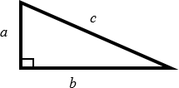
- In a right-angled triangle the longest side is called the hypotenuse.
- Pythagoras’ theorem states that for a right-angled triangle the square of the hypotenuse is equal to the sum of the squares of the other two sides.
c² = a² + b²

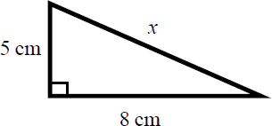
Examples
Example 1 Calculate the length of the hypotenuse.
Give your answer to 3 significant figures.

c² = a² + b²  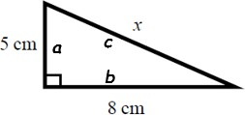  x² = 5² + 8²  x² = 25 + 64  x² = 89  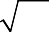  x = 89  x = 9.433 981 13...  x = 9.43 cm | - Always start by stating the formula for Pythagoras’ theorem and labelling the hypotenuse c and the other two sides a and b.  - Substitute the values of a, b and c into the formula for Pythagoras' theorem.  - Use a calculator to find the square root.  - Round your answer to 3 significant figures and write the units with your answer.

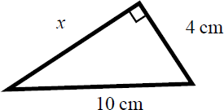
Example 2 Calculate the length x.
Give your answer in surd form.

c² = a² + b²  10² = x² + 4²  100 = x² + 16  x² = 84  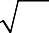  x = 84  x = 2 21 cm | - Always start by stating the formula for Pythagoras' theorem.  - Substitute the values of a, b and c into the formula for Pythagoras' theorem.  - Simplify the surd where possible and write the units in your answer.

Practice

- Work out the length of the unknown side in each triangle. Give your answers correct to 3 significant figures.
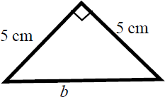
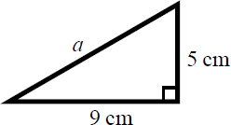
a b
c d
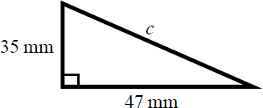
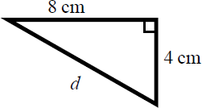

- Work out the length of the unknown side in each triangle. Give your answers in surd form.
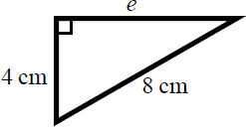
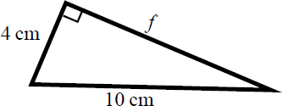
a b

c d
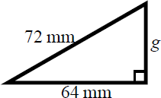
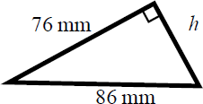

- Work out the length of the unknown side in each triangle. Give your answers in surd form.
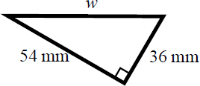
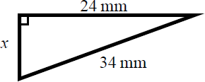
a b

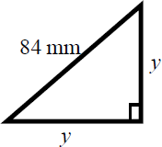
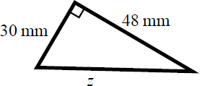
c d

- A rectangle has length 84 mm and width 45 mm. Calculate the length of the diagonal of the rectangle. Give your answer correct to 3 significant figures.
Hint
Draw a sketch of the rectangle.

Extend
- A yacht is 40 km due North of a lighthouse.
Hint
Draw a diagram using the information given in the question.
A rescue boat is 50 km due East of the same lighthouse. Work out the distance between the yacht and the rescue boat. Give your answer correct to 3 significant figures.

- Points A and B are shown on the diagram. Work out the length of the line AB.
Give your answer in surd form.
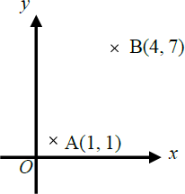

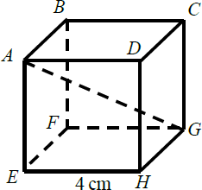
- A cube has length 4 cm.
Work out the length of the diagonal AG. Give your answer in surd form.

Answers

1 | a  c | 10.3 cm  58.6 mm | b  d | 7.07 cm  8.94 cm
2 | a | 4 3 cm | b | 2 21 cm
 | c | 8 17 mm | d | 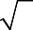  18 5 mm
3 | a | 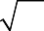  18 13 mm | b | 2 145 mm
 | c | 42 2 mm | d | 6 89 mm
4 | 95.3 mm
5 | 64.0 km
6 | 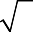  3 5 units
7 | 4 3 cm

Proportion
A LEVEL LINKS
Scheme of work: 2a. Straight-line graphs, parallel/perpendicular, length and area problems

Key points
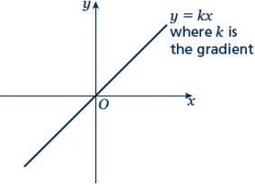
  - Two quantities are in direct proportion when, as one quantity increases, the other increases at the same rate. Their ratio remains the same.
  - ‘y is directly proportional to x’ is written as y ∝ x. If y ∝ x then y = kx, where k is a constant.
  - When x is directly proportional to y, the graph is a straight line passing through the origin.

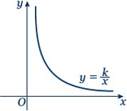
  - Two quantities are in inverse proportion when, as one quantity increases, the other decreases at the same rate.
  - ‘y is inversely proportional to x’ is written as y ∝ ¹ .
x

If y ∝ ¹
x
then y = k , where k is a constant.
x

  - When x is inversely proportional to y the graph is the same shape as the graph of y = ¹
x

Examples
Example 1 y is directly proportional to x.
When y = 16, x = 5.
- Find x when y = 30.
- Sketch the graph of the formula.

a y ∝ x  y = kx  16 = k × 5  k = 3.2  y = 3.2x  When y = 30, 30 = 3.2 × x  x = 9.375 | - Write y is directly proportional to x, using the symbol ∝ .  - Write the equation using k.  - Substitute y = 16 and x = 5 into  y = kx.  - Solve the equation to find k.  - Substitute the value of k back into the equation y = kx.  - Substitute y = 30 into y = 3.2x and solve to find x when y = 30.

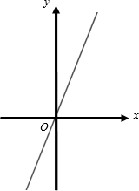  b | 7 The graph of y = 3.2x is a straight line passing through (0, 0) with a gradient of 3.2.

Example 2 y is directly proportional to x².
When x = 3, y = 45.
- Find y when x = 5.
- Find x when y = 20.

a y ∝ x²  y = kx²  45 = k × 3²  k = 5  y = 5x²  When x = 5,  y = 5 × 5²  y = 125  b 20 = 5 × x²  x² = 4  x = ±2 | - Write y is directly proportional to x², using the symbol ∝ .  - Write the equation using k.  - Substitute y = 45 and x = 3 into  y = kx².  - Solve the equation to find k.  - Substitute the value of k back into the equation y = kx².  - Substitute x = 5 into y = 5x² and solve to find y when x = 5.  - Substitute y = 20 into y = 5x² and solve to find x when y = 4.

Example 3 P is inversely proportional to Q.
When P = 100, Q = 10.
Find Q when P = 20.

P ∝ 1  Q  P = k  Q  100 = k  10  k = 1000  P = 1000  Q  20 = 1000  Q  Q = 1000 = 50  20 | - Write P is inversely proportional to Q, using the symbol ∝ .  - Write the equation using k.  - Substitute P = 100 and Q = 10.  - Solve the equation to find k.  - Substitute the value of k into P = k  Q  - Substitute P = 20 into P = 1000 and  Q  solve to find Q when P = 20.

Practice
Hint
Substitute the values given for P and h into the formula to calculate k.
- Paul gets paid an hourly rate. The amount of pay (£P) is directly
proportional to the number of hours (h) he works.
When he works 8 hours he is paid £56.
If Paul works for 11 hours, how much is he paid?

- x is directly proportional to y. x = 35 when y = 5.
  - Find a formula for x in terms of y.
  - Sketch the graph of the formula.
  - Find x when y = 13.
  - Find y when x = 63.

- Q is directly proportional to the square of Z. Q = 48 when Z = 4.
  - Find a formula for Q in terms of Z.
  - Sketch the graph of the formula.
  - Find Q when Z = 5.
  - Find Z when Q = 300.

- y is directly proportional to the square of x. x = 2 when y = 10.
  - Find a formula for y in terms of x.
  - Sketch the graph of the formula.
  - Find x when y = 90.

- B is directly proportional to the square root of C. C = 25 when B = 10.
  - Find B when C = 64.
  - Find C when B = 20.

- C is directly proportional to D. C = 100 when D = 150.
Find C when D = 450.

- y is directly proportional to x. x = 27 when y = 9.
Find x when y = 3.7.

- m is proportional to the cube of n. m = 54 when n = 3.
Find n when m = 250.

Extend
- s is inversely proportional to t.
  - Given that s = 2 when t = 2, find a formula for s in terms of t.
  - Sketch the graph of the formula.
  - Find t when s = 1.

- a is inversely proportional to b. a = 5 when b = 20.
  - Find a when b = 50.
  - Find b when a = 10.

- v is inversely proportional to w. w = 4 when v = 20.
  - Find a formula for v in terms of w.
  - Sketch the graph of the formula.
  - Find w when v = 2.

- L is inversely proportional to W. L = 12 when W = 3.
Find W when L = 6.

- s is inversely proportional to t. s = 6 when t = 12.
  - Find s when t = 3.
  - Find t when s = 18.

- y is inversely proportional to x². y = 4 when x = 2.
Find y when x = 4.

- y is inversely proportional to the square root of x. x = 25 when y = 1.
Find x when y = 5.

- a is inversely proportional to b. a = 0.05 when b = 4.
  - Find a when b = 2.
  - Find b when a = 2.

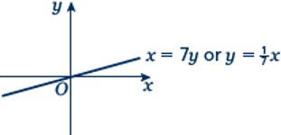
Answers
1 | £77
2 | a | x = 7y | b
3 | c a | 91  Q = 3Z² | d b | 9
4 | c a | 75  y = 2.5x² | d b | ±10
 | c | ±6
5 | a | 16 | b | 100
6 | 300
7 | 11.1
8 | 5
9 | a | s = 4 | b
 | c | 4
10 | a | 2 | b | 10

t

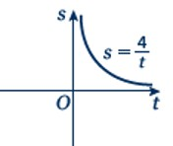
11 a
v = 80 b
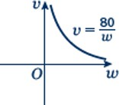
w

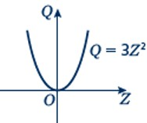
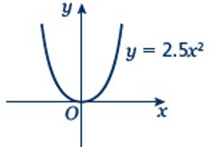
  - 40

12 6
13 a | 24 | b | 4
14 1
15 1
16 a | 0.1 | b | 0.1

Circle theorems
A LEVEL LINKS
Scheme of work: 2b. Circles – equation of a circle, geometric problems on a grid

Key points
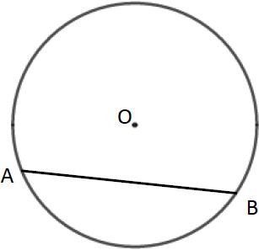
- A chord is a straight line joining two points on the circumference of a circle.
So AB is a chord.

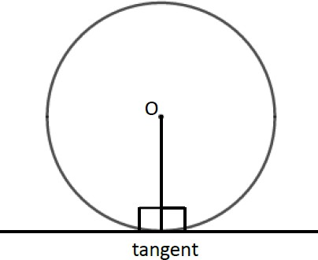
- A tangent is a straight line that touches the circumference of a circle at only one point.
The angle between a tangent and the radius is 90°.

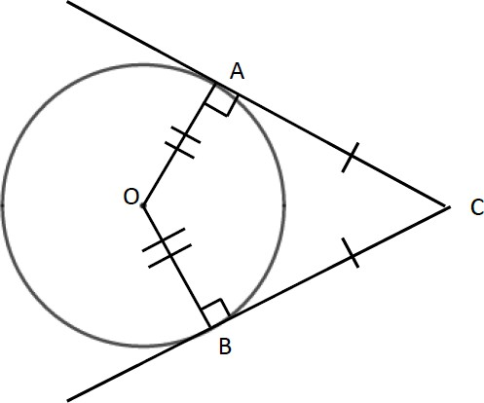
- Two tangents on a circle that meet at a point outside the circle are equal in length.
So AC = BC.

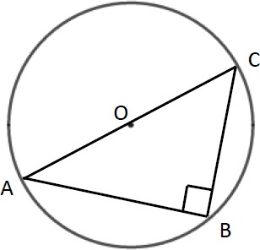
- The angle in a semicircle is a right angle. So angle ABC = 90°.

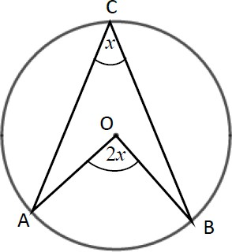
- When two angles are subtended by the same arc, the angle at the centre of a circle is twice the angle at the circumference.
So angle AOB = 2 × angle ACB.

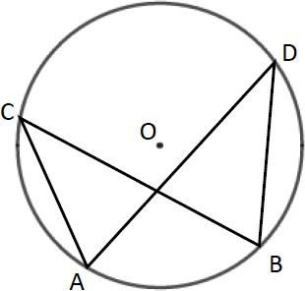
- Angles subtended by the same arc at the circumference are equal. This means that angles in the same segment are equal.
So angle ACB = angle ADB and angle CAD = angle CBD.

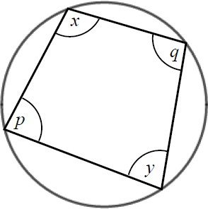
- A cyclic quadrilateral is a quadrilateral with all four vertices on the circumference of a circle. Opposite angles in a cyclic quadrilateral total 180°. So x + y = 180° and p + q = 180°.

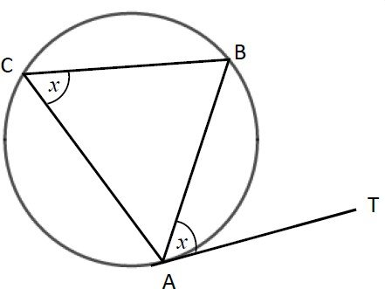
- The angle between a tangent and chord is equal to the angle in the alternate segment, this is known as the alternate segment theorem.
So angle BAT = angle ACB.

Examples
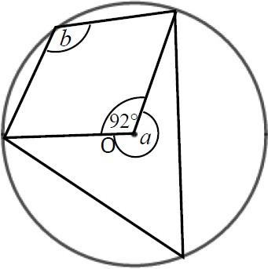
Example 1 Work out the size of each angle
marked with a letter.
Give reasons for your answers.

Angle a = 360° − 92°  = 268°  as the angles in a full turn total 360°.  Angle b = 268° ÷ 2  = 134°  as when two angles are subtended by the same arc, the angle at the centre of a circle is twice the angle at the circumference. | - The angles in a full turn total 360°.  - Angles a and b are subtended by the same arc, so angle b is half of angle a.

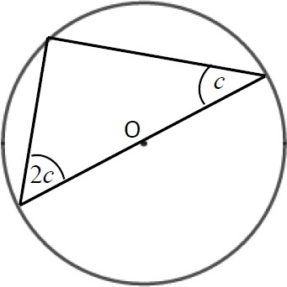
Example 2 Work out the size of the angles in the triangle.
Give reasons for your answers.

Angles are 90°, 2c and c.  90° + 2c + c = 180°  90° + 3c = 180°  3c = 90°  c = 30°  2c = 60°  The angles are 30°, 60° and 90° as the angle in a semi-circle is a right angle and the angles in a triangle total 180°. | - The angle in a semicircle is a right angle.  - Angles in a triangle total 180°.  - Simplify and solve the equation.

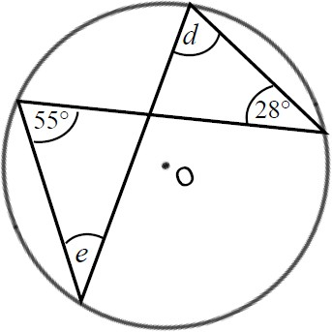
Example 3 Work out the size of each angle marked with a letter.
Give reasons for your answers.

Angle d = 55° as angles subtended by the same arc are equal.  Angle e = 28° as angles subtended by the same arc are equal. | - Angles subtended by the same arc are equal so angle 55° and angle d are equal.  - Angles subtended by the same arc are equal so angle 28° and angle e are equal.

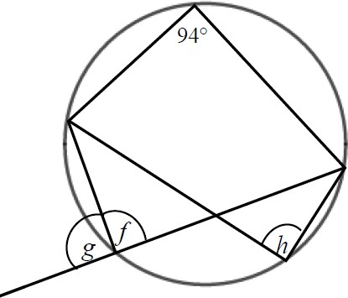
Example 4 Work out the size of each angle marked with a letter.
Give reasons for your answers.

Angle f = 180° − 94°  = 86°  as opposite angles in a cyclic quadrilateral total 180°. | 1 Opposite angles in a cyclic quadrilateral total 180° so angle 94° and angle f total 180°.  (continued on next page)

Angle g = 180° − 86°  = 84°  as angles on a straight line total 180°.  Angle h = angle f = 86° as angles subtended by the same arc are equal. | - Angles on a straight line total 180° so angle f and angle g total 180°.  - Angles subtended by the same arc are equal so angle f and angle h are equal.

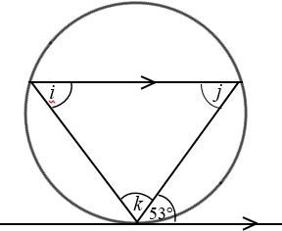
Example 5 Work out the size of each angle marked with a letter.
Give reasons for your answers.

Angle i = 53° because of the alternate segment theorem.  Angle j = 53° because it is the alternate angle to 53°.  Angle k = 180° − 53° − 53°  = 74°  as angles in a triangle total 180°. | - The angle between a tangent and chord is equal to the angle in the alternate segment.  - As there are two parallel lines, angle 53° is equal to angle j because they are alternate angles.  - The angles in a triangle total 180°, so i + j + k = 180°.

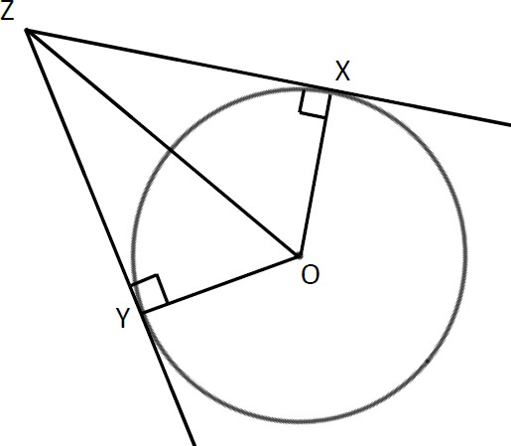
Example 6 XZ and YZ are two tangents to a circle with centre O. Prove that triangles XZO and YZO are congruent.

Angle OXZ = 90° and angle OYZ = 90° as the angles in a semicircle are right angles.  OZ is a common line and is the hypotenuse in both triangles.  OX = OY as they are radii of the same circle.  So triangles XZO and YZO are congruent, RHS. | For two triangles to be congruent you need to show one of the following.  - All three corresponding sides are equal (SSS).  - Two corresponding sides and the included angle are equal (SAS).  - One side and two corresponding angles are equal (ASA).  - A right angle, hypotenuse and a shorter side are equal (RHS).

Practice
- Work out the size of each angle marked with a letter. Give reasons for your answers.
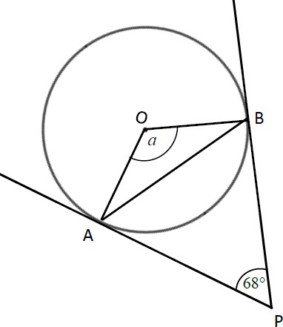
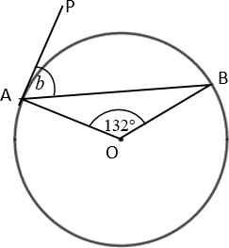
a b

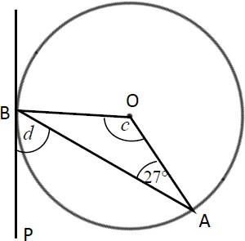
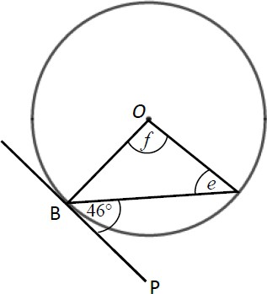
c d
A

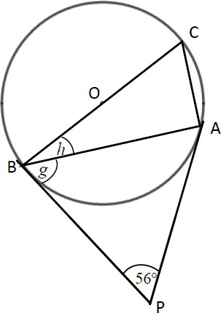
e

- Work out the size of each angle marked with a letter. Give reasons for your answers.
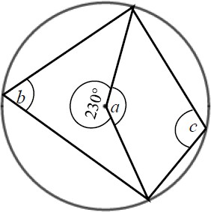
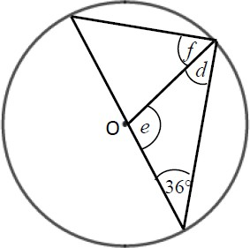
a b

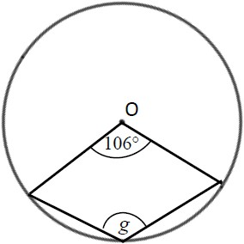
c
Hint
The reflex angle at point O and angle g are subtended by the same arc. So the reflex angle is twice the size of angle g.

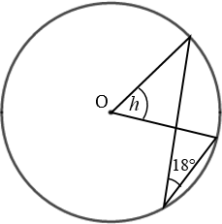
d
Hint
Angle 18° and angle h are subtended by the same arc.

- Work out the size of each angle marked with a letter. Give reasons for your answers.
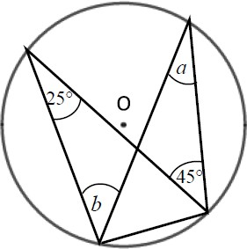
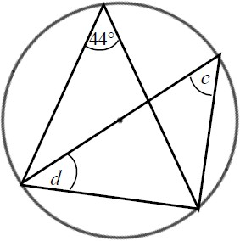
a b
Hint
One of the angles is in a semicircle.

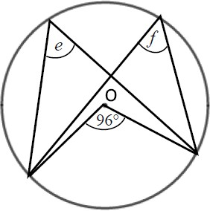
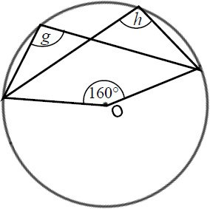
c d

- Work out the size of each angle marked with a letter. Give reasons for your answers.
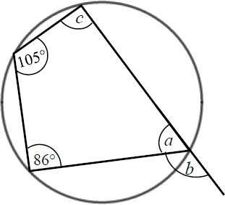
a
Hint
An exterior angle of a cyclic quadrilateral is equal to the opposite interior angle.

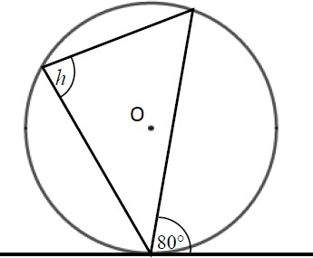
b c
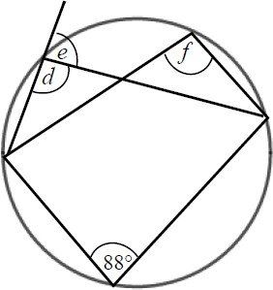

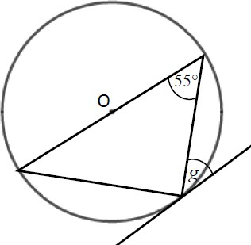
d
Hint
One of the angles is in a semicircle.

Extend
- Prove the alternate segment theorem.

Answers
- a a = 112°, angle OAP = angle OBP = 90° and angles in a quadrilateral total 360°.
  - b = 66°, triangle OAB is isosceles, Angle OAP = 90° as AP is tangent to the circle.
  - c = 126°, triangle OAB is isosceles.
d = 63°, Angle OBP = 90° as BP is tangent to the circle.
  - e = 44°, the triangle is isosceles, so angles e and angle OBA are equal. The angle OBP = 90° as BP is tangent to the circle.
f = 92°, the triangle is isosceles.
  - g = 62°, triangle ABP is isosceles as AP and BP are both tangents to the circle.
h = 28°, the angle OBP = 90°.

- a a = 130°, angles in a full turn total 360°.
b = 65°, the angle at the centre of a circle is twice the angle at the circumference.
c = 115°, opposite angles in a cyclic quadrilateral total 180°.
  - d = 36°, isosceles triangle.
e = 108°, angles in a triangle total 180°.
f = 54°, angle in a semicircle is 90°.
  - g = 127°, angles at a full turn total 360°, the angle at the centre of a circle is twice the angle at the circumference.
  - h = 36°, the angle at the centre of a circle is twice the angle at the circumference.

- a a = 25°, angles in the same segment are equal.
b = 45°, angles in the same segment are equal.
  - c = 44°, angles in the same segment are equal.
d = 46°, the angle in a semicircle is 90° and the angles in a triangle total 180°.
  - e = 48°, the angle at the centre of a circle is twice the angle at the circumference.
f = 48°, angles in the same segment are equal.
  - g = 100°, angles at a full turn total 360°, the angle at the centre of a circle is twice the angle at the circumference.
h = 100°, angles in the same segment are equal.

- a a = 75°, opposite angles in a cyclic quadrilateral total 180°.
b = 105°, angles on a straight line total 180°.
c = 94°, opposite angles in a cyclic quadrilateral total 180°.
  - d = 92°, opposite angles in a cyclic quadrilateral total 180°.
e = 88°, angles on a straight line total 180°.
f = 92°, angles in the same segment are equal.
  - h = 80°, alternate segment theorem.
  - g = 35°, alternate segment theorem and the angle in a semicircle is 90°.

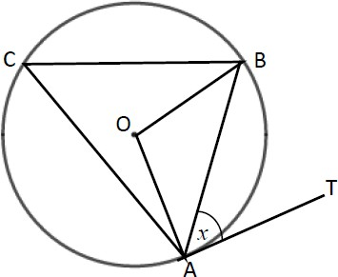
- Angle BAT = x.
Angle OAB = 90° − x because the angle between the tangent and the radius is 90°.
OA = OB because radii are equal.
Angle OAB = angle OBA because the base of isosceles triangles are equal.
Angle AOB = 180° − (90° − x) − (90° − x) = 2x
because angles in a triangle total 180°.
Angle ACB = 2x ÷ 2 = x because the angle at the centre is twice the angle at the circumference.

Trigonometry in right-angled triangles
A LEVEL LINKS
Scheme of work: 4a. Trigonometric ratios and graphs

Key points
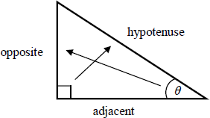
- In a right-angled triangle:
  - the side opposite the right angle is called the hypotenuse
  - the side opposite the angle θ is called the opposite
  - the side next to the angle θ is called the adjacent.

- In a right-angled triangle:
  - the ratio of the opposite side to the hypotenuse is the sine of angle θ, sinθ = opp
hyp
  - the ratio of the adjacent side to the hypotenuse is the cosine of angle θ, cosθ = adj
hyp
  - the ratio of the opposite side to the adjacent side is the tangent of angle θ, tanθ = opp
adj

- If the lengths of two sides of a right-angled triangle are given, you can find a missing angle using the inverse trigonometric functions: sin⁻¹, cos⁻¹, tan⁻¹.

- The sine, cosine and tangent of some angles may be written exactly.

 | 0 | 30° | 45° | 60° | 90°
sin | 0 | 1 2 | 2  2 | 3  2 | 1
cos | 1 | 3  2 | 2  2 | 1 2 | 0
tan | 0 | 3  3 | 1 | 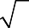  3

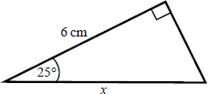
Examples
Example 1 Calculate the length of side x.
Give your answer correct to 3 significant figures.

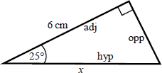  cosθ = adj  hyp  cos 25° = 6  x  x = 6 cos 25°  x = 6.620 267 5...  x = 6.62 cm | - Always start by labelling the sides.  - You are given the adjacent and the hypotenuse so use the cosine ratio.  - Substitute the sides and angle into the cosine ratio.  - Rearrange to make x the subject.  - Use your calculator to work out  6 ÷ cos 25°.  - Round your answer to 3 significant figures and write the units in your answer.

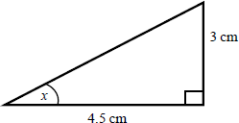
Example 2 Calculate the size of angle x.
Give your answer correct to 3 significant figures.

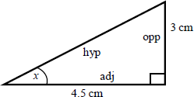  tanθ = opp  adj  tan x = 3  4.5  x = tan^{–1} ⎛ 3 ⎞  ⎜ 4.5 ⎟  ⎝ ⎠  x = 33.690 067 5...  x = 33.7° | - Always start by labelling the sides.  - You are given the opposite and the adjacent so use the tangent ratio.  - Substitute the sides and angle into the tangent ratio.  - Use tan⁻¹ to find the angle.  - Use your calculator to work out tan^{–1}(3 ÷ 4.5).  - Round your answer to 3 significant figures and write the units in your answer.

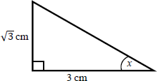
Example 3 Calculate the exact size of angle x.

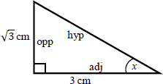  tanθ = opp  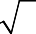  adj  tan x = 3 3  x = 30° | - Always start by labelling the sides.  - You are given the opposite and the adjacent so use the tangent ratio.  - Substitute the sides and angle into the tangent ratio.  - Use the table from the key points to find the angle.

Practice

- Calculate the length of the unknown side in each triangle. Give your answers correct to 3 significant figures.
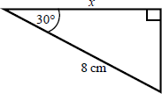
a b
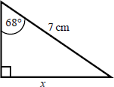
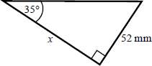
c d
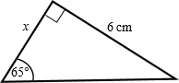

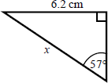
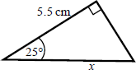
e f

- Calculate the size of angle x in each triangle. Give your answers correct to 1 decimal place.
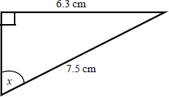
a b
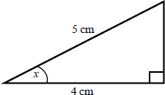
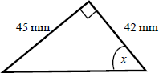
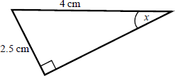
c d

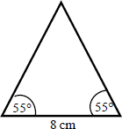
- Work out the height of the isosceles triangle. Give your answer correct to 3 significant figures.
Hint:
Split the triangle into two right-angled triangles.

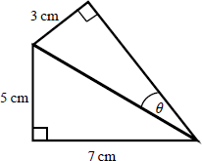
- Calculate the size of angle θ.
Give your answer correct to 1 decimal place.
Hint:
First work out the length of the common side to both triangles, leaving your answer in surd form.

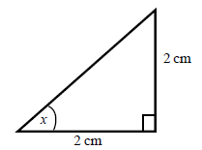
- Find the exact value of x in each triangle.
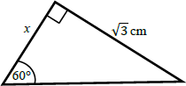
a b

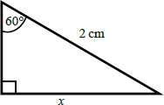
c d
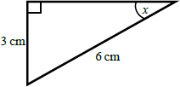

The cosine rule
A LEVEL LINKS
Scheme of work: 4a. Trigonometric ratios and graphs
Textbook: Pure Year 1, 9.1 The cosine rule

Key points
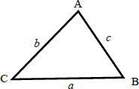
- a is the side opposite angle A.
b is the side opposite angle B.
c is the side opposite angle C.

- You can use the cosine rule to find the length of a side when two sides and the included angle are given.
- To calculate an unknown side use the formula a² = b² + c² − 2bc cos A .

- Alternatively, you can use the cosine rule to find an unknown angle if the lengths of all three sides are given.
b² + c² − a²
•
To calculate an unknown angle use the formula cos A = .
2bc

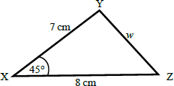
Examples
Example 4 Work out the length of side w.
Give your answer correct to 3 significant figures.

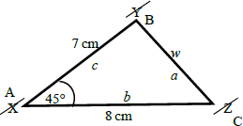  a² = b² + c² − 2bc cos A  w² = 8² + 7² − 2 × 8× 7 ×cos 45°  w² = 33.804 040 51...  w = 33.804 04051  w = 5.81 cm | - Always start by labelling the angles and sides.  - Write the cosine rule to find the side.  - Substitute the values a, b and A into the formula.  - Use a calculator to find w² and then w.  - Round your final answer to 3 significant figures and write the units in your answer.

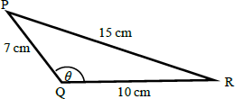
Example 5 Work out the size of angle θ.
Give your answer correct to 1 decimal place.

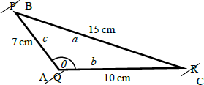  b² + c² − a²  cos A =  2bc  2 2 2  cosθ = 10 + 7 −15  2 ×10 × 7  cosθ = −76  140  θ = 122.878 349...  θ = 122.9° | - Always start by labelling the angles and sides.  - Write the cosine rule to find the angle.  - Substitute the values a, b and c into the formula.  - Use cos⁻¹ to find the angle.  - Use your calculator to work out cos^{–1}(–76 ÷ 140).  - Round your answer to 1 decimal place and write the units in your answer.

Practice
- Work out the length of the unknown side in each triangle. Give your answers correct to 3 significant figures.
a b
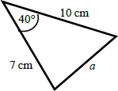
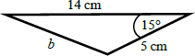

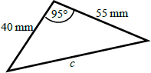
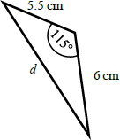
c d

- Calculate the angles labelled θ in each triangle. Give your answer correct to 1 decimal place.
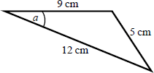
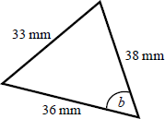
a b

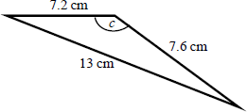
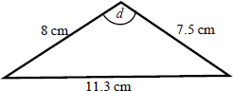
c d

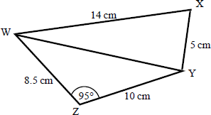
- a Work out the length of WY. Give your answer correct to 3 significant figures.

b Work out the size of angle WXY. Give your answer correct to
1 decimal place.

The sine rule
A LEVEL LINKS
Scheme of work: 4a. Trigonometric ratios and graphs
Textbook: Pure Year 1, 9.2 The sine rule

Key points
- a is the side opposite angle A.
b is the side opposite angle B.
c is the side opposite angle C.

- You can use the sine rule to find the length of a side when its opposite angle and another opposite side and angle are given.

- To calculate an unknown side use the formula
a

sin A
= b
sin B
= c .
sin C

- Alternatively, you can use the sine rule to find an unknown angle if the opposite side and another opposite side and angle are given.
- To calculate an unknown angle use the formula sin A = sin B = sin C .
a b c

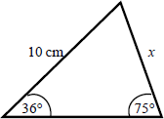
Examples
Example 6 Work out the length of side x.
Give your answer correct to 3 significant figures.

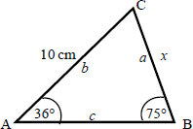  a = b  sin A sin B  x = 10 sin 36° sin 75°  x = 10 × sin 36°  sin 75°  x = 6.09 cm | - Always start by labelling the angles and sides.  - Write the sine rule to find the side.  - Substitute the values a, b, A and B  into the formula.  - Rearrange to make x the subject.  - Round your answer to 3 significant figures and write the units in your answer.

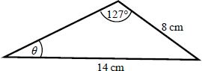
Example 7 Work out the size of angle θ.
Give your answer correct to 1 decimal place.

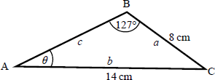  sin A = sin B a b  sinθ = sin127°  8 14  sinθ = 8 × sin127°  14  θ = 27.2° | - Always start by labelling the angles and sides.  - Write the sine rule to find the angle.  - Substitute the values a, b, A and B  into the formula.  - Rearrange to make sin θ the subject.  - Use sin⁻¹ to find the angle. Round your answer to 1 decimal place and write the units in your answer.

Practice
- Find the length of the unknown side in each triangle. Give your answers correct to 3 significant figures.

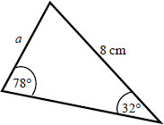
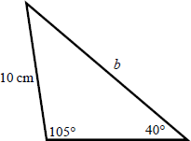
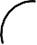
a b

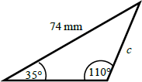
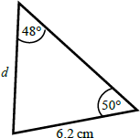
c d

- Calculate the angles labelled θ in each triangle. Give your answer correct to 1 decimal place.

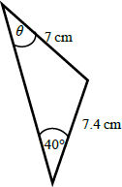
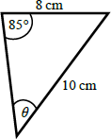
a b

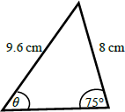
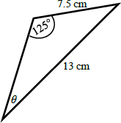
c d

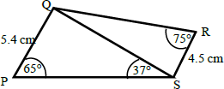
- a Work out the length of QS.
Give your answer correct to 3 significant figures.

b Work out the size of angle RQS.
Give your answer correct to 1 decimal place.

Areas of triangles
A LEVEL LINKS
Scheme of work: 4a. Trigonometric ratios and graphs
Textbook: Pure Year 1, 9.3 Areas of triangles

Key points
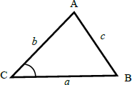
  - a is the side opposite angle A.
b is the side opposite angle B.
c is the side opposite angle C.
  - The area of the triangle is 1 ab sin C .
2

Examples
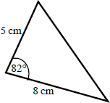
Example 8 Find the area of the triangle.

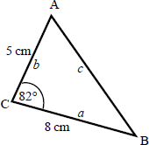  Area = 1 ab sin C  2  Area = 1 × 8× 5×sin 82°  2  Area = 19.805 361...  Area = 19.8 cm² | - Always start by labelling the sides and angles of the triangle.  - State the formula for the area of a triangle.  - Substitute the values of a, b and C into the formula for the area of a triangle.  - Use a calculator to find the area.  - Round your answer to 3 significant figures and write the units in your answer.

Practice
- Work out the area of each triangle.
Give your answers correct to 3 significant figures.

a b
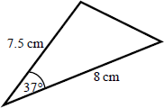
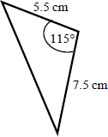

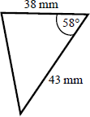
c

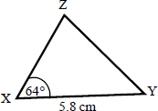
- The area of triangle XYZ is 13.3 cm². Work out the length of XZ.
Hint:
Rearrange the formula to make a side the subject.

Extend
Hint:
For each one, decide whether to use the cosine or sine rule.
- Find the size of each lettered angle or side.
Give your answers correct to 3 significant figures.

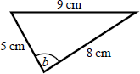
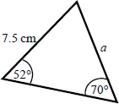
a b

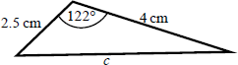
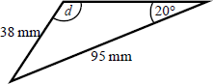
c d

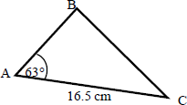
- The area of triangle ABC is 86.7 cm². Work out the length of BC.
Give your answer correct to 3 significant figures.

Answers

1 | a | 6.49 cm | b | 6.93 cm | c | 2.80 cm
 | d | 74.3 mm | e | 7.39 cm | f | 6.07 cm
2 | a | 36.9° | b | 57.1° | c | 47.0° | d | 38.7°
3 5.71 cm

4 20.4°

5 | a | 45° | b | 1 cm | c | 30° | d | 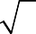  3 | cm
6 a |  | 6.46 cm | b | 9.26 cm | c | 70.8 mm | d | 9.70 cm
7 a |  | 22.2° | b | 52.9° | c | 122.9° | d | 93.6°
8 a |  | 13.7 cm | b | 76.0°
9 a |  | 4.33 cm | b | 15.0 cm | c | 45.2 mm | d | 6.39 cm
10 a |  | 42.8° | b | 52.8° | c | 53.6° | d | 28.2°
11 a  12 a |  | 8.13 cm  18.1 cm² | b  b | 32.3°  18.7 cm² | c | 693 mm²
13 5.10 |  | cm
14 a |  | 6.29 cm | b | 84.3° | c | 5.73 cm | d | 58.8°
15 15.3 |  | cm

Rearranging equations
A LEVEL LINKS
Scheme of work: 6a. Definition, differentiating polynomials, second derivatives
Textbook: Pure Year 1, 12.1 Gradients of curves

Key points
  - To change the subject of a formula, get the terms containing the subject on one side and everything else on the other side.
  - You may need to factorise the terms containing the new subject.

Examples
Example 1 Make t the subject of the formula v = u + at.

v = u + at  v − u = at  t = v − u  a | - Get the terms containing t on one side and everything else on the other side.  - Divide throughout by a.

Example 2 Make t the subject of the formula r = 2t − πt.

r = 2t − πt  r = t(2 − π)  t = r  2 − π | - All the terms containing t are already on one side and everything else is on the other side.  - Factorise as t is a common factor.  - Divide throughout by 2 − π.

Example 3 Make t the subject of the formula
t + r = 3t .
5 2

t + r = 3t  5 2  2t + 2r = 15t 2r = 13t  t = 2r  13 | - Remove the fractions first by multiplying throughout by 10.  - Get the terms containing t on one side and everything else on the other side and simplify.  - Divide throughout by 13.

Example 4 Make t the subject of the formula r = 3t + 5 .
t −1

r = 3t + 5  t −1  r(t − 1) = 3t + 5  rt − r = 3t + 5 rt − 3t = 5 + r t(r − 3) = 5 + r  t = 5 + r  r − 3 | - Remove the fraction first by multiplying throughout by t − 1.  - Expand the brackets.  - Get the terms containing t on one side and everything else on the other side.  - Factorise the LHS as t is a common factor.  - Divide throughout by r − 3.

Practice
Change the subject of each formula to the letter given in the brackets.
1 C = πd [d] 2 P = 2l + 2w [w] 3 D = S T

[T]

4 p = q − r t
[t] 5 u = at – 1 t [t] 6 V = ax + 4x [x]
2

7 y − 7x = 7 − 2 y
2 3
[y] 8
x = 2a −1
- − a
[a] 9
x = b − c
d
[d]

10 h = 7g − 9
2 + g
[g] 11 e(9 + x) = 2e + 1 [e] 12
y = 2x + 3
- − x
[x]

- Make r the subject of the following formulae.

a A = πr² b
V = 4 π r³
3
c P = πr + 2r d
V = 2 π r ²h
3

- Make x the subject of the following formulae.
a xy = ab b 4π cx = 3z

z cd d py²

- Make sin B the subject of the formula
a

sin A
= b

sin B

- Make cos B the subject of the formula b² = a² + c² – 2ac cos B.

Extend
- Make x the subject of the following equations.

  - p (sx + t) = x −1
q
  - p (ax + 2 y) = 3 p (x − y) q q²

Answers

- d = C
π

- w = P − 2l
2

- T = S D

- t = q − r p
- t =
2u 2a − 1
- x =
V

a + 4

7 y = 2 + 3x 8
a = 3x + 1
x + 2
9 d = b − c x

10 g = 2h + 9
- − h
A
π
11 e =
1
x + 7
3V
3
4π
12 x = 4 y − 3
2 + y

- a
3V
2π h
r = b r =

  - r =
P
π + 2
  - r =

- a
x = abz
cdy
b x =
3dz 4π cpy²

- sin B = b sin A
a

- cos B =
a² + c² − b²
2ac

- a
x = q + pt
b x = 3 py + 2 pqy = y(3 + 2q)

q − ps
3 p − apq 3 − aq

Volume and surface area of 3D shapes
A LEVEL LINKS
Scheme of work: 6b. Gradients, tangents, normals, maxima and minima

Key points
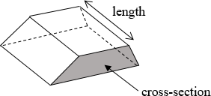
- Volume of a prism = cross-sectional area × length.
- The surface area of a 3D shape is the total area of all its faces.

- Volume of a pyramid = ¹
3
× area of base × vertical height.

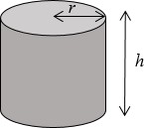
- Volume of a cylinder = πr²h
- Total surface area of a cylinder = 2πr² + 2πrh

- Volume of a sphere =
4 π r³
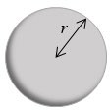
3

- Surface area of a sphere = 4πr²

- Volume of a cone =
1 π r ²h
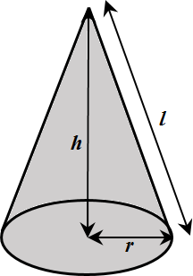
3

- Total surface area of a cone = πrl + πr²

Examples
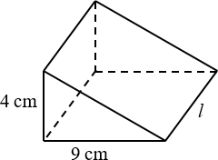
Example 1 The triangular prism has volume 504 cm³.
Work out its length.

V = ¹ bhl  2  504 = ¹ × 9 × 4 × l  2  504 = 18 × l  l = 504 ÷ 18  = 28 cm | - Write out the formula for the volume of a triangular prism.  - Substitute known values into the formula.  - Simplify  - Rearrange to work out l.  - Remember the units.

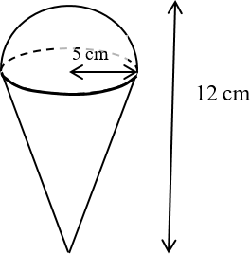
Example 2 Calculate the volume of the 3D solid.
Give your answer in terms of π.

Total volume = volume of hemisphere  + Volume of cone  = 1 of 4 πr³ + 1 πr²h  2 3 3  Total volume = 1 × 4 × π × 5³  2 3  1  + 3 × π × 5² × 7  425  = 3 π cm³ | - The solid is made up of a hemisphere radius 5 cm and  a cone with radius 5 cm and height 12 − 5 = 7 cm.  - Substitute the measurements into the formula for the total volume.  - Remember the units.

Practice
- Work out the volume of each solid.
Leave your answers in terms of π where appropriate.

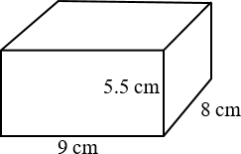
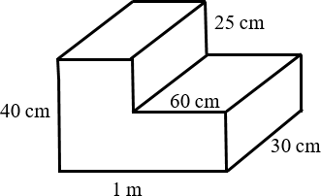
a b

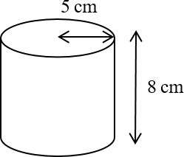
c d
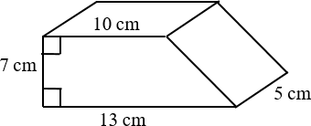

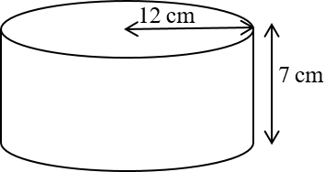
e f a sphere with radius 7 cm

g a sphere with diameter 9 cm h a hemisphere with radius 3 cm

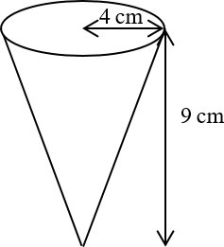
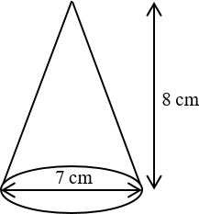
i j

- A cuboid has width 9.5 cm, height 8 cm and volume 1292 cm³. Work out its length.

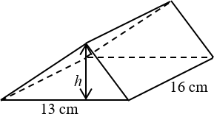
- The triangular prism has volume 1768 cm³. Work out its height.

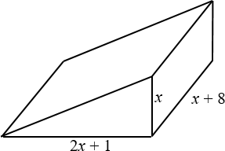
Extend
- The diagram shows a solid triangular prism. All the measurements are in centimetres. The volume of the prism is V cm³.
Find a formula for V in terms of x. Give your answer in simplified form.

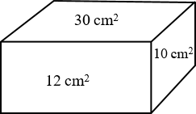
- The diagram shows the area of each of three faces of a cuboid.
The length of each edge of the cuboid is a whole number of centimetres.
Work out the volume of the cuboid.

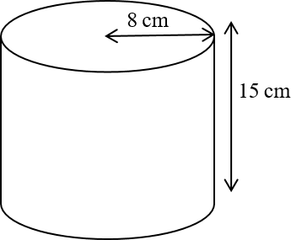
- The diagram shows a large catering size tin of beans in the shape of a cylinder.
The tin has a radius of 8 cm and a height of 15 cm. A company wants to make a new size of tin.
The new tin will have a radius of 6.7 cm.
It will have the same volume as the large tin. Calculate the height of the new tin.
Give your answer correct to one decimal place.

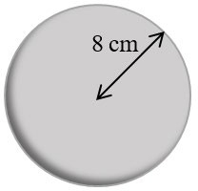
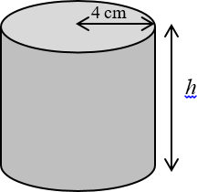
- The diagram shows a sphere and a solid cylinder. The sphere has radius 8 cm.
The solid cylinder has a base radius of 4 cm and a height of h cm.
The total surface area of the cylinder is half the total surface area of the sphere.
Work out the ratio of the volume of the sphere to the volume of the cylinder.
Give your answer in its simplest form.

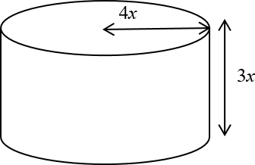
- The diagram shows a solid metal cylinder. The cylinder has base radius 4x and height 3x.
The cylinder is melted down and made into a sphere of radius r.
Find an expression for r in terms of x.

Answers
1 a V = 396 cm³ b V = 75 000 cm³
c V = 402.5 cm³ d V = 200π cm³
e | V = 1008π cm³ | f | V= | 1372 π | cm³
g | V = 121.5π cm³ | h | V = 18π cm³
i | V = 48π cm³ | j | V = 98 π cm³  3

3

- 17 cm

- 17 cm

- V = x³ + 17 x² + 4x
2

- 60 cm³

- 21.4 cm

- 32 : 9

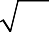
- r = ³ 36x

Area under a graph
A LEVEL LINKS
Scheme of work: 7b. Definite integrals and areas under curves

Key points
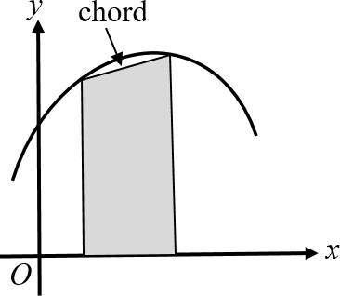
  - To estimate the area under a curve, draw a chord between the two points you are finding the area between and straight lines down to the horizontal axis to create a trapezium.
The area of the trapezium is an approximation for the area under a curve.

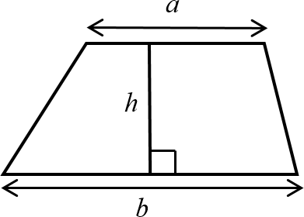
  - The area of a trapezium = 1 h(a + b)
2

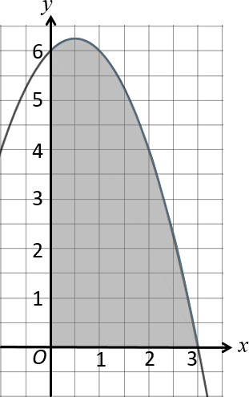
Examples

Example 1 Estimate the area of the region between the curve
y = (3 − x)(2 + x) and the x-axis from x = 0 to x = 3. Use three strips of width 1 unit.

Trapezium 1:
a₁ = 6 − 0 = 6 , b₁ = 6 − 0 = 6
Trapezium 2:
a₂ = 6 − 0 = 6 , b₂ = 4 − 0 = 4
Trapezium 3:
a₃ = 4 − 0 = 4 , a₃ = 0 − 0 = 0
(continued on next page)
- Use a table to record the value of y
on the curve for each value of x.
- Work out the dimensions of each trapezium. The distances between the y-values on the curve and the x-axis give the values for a.

x | 0 | 1 | 2 | 3
y = (3 − x)(2 + x) | 6 | 6 | 4 | 0

Trapezium 1:
a₁ = 7 − 7 = 0 , b₁ = 12 − 6 = 6
Trapezium 2:
a₂ = 12 − 6 = 6 , b₂ = 13 − 5 = 8
Trapezium 3:
a₃ = 13 − 5 = 8 , a₃ = 4 − 4 = 0
1 h(a + b ) = 1 × 2(0 + 6) = 6
2
1 1
2
1 h(a + b ) = 1 × 2(6 + 8) = 14
2
2 2
2
1 h(a + b ) = 1 × 2(8 + 0) = 8
2
3 3
2
Area = 6 + 14 + 8 = 28 units²
5 Work out the total area. Remember to give units with your answer.
4 Work out the area of each trapezium. h = 2 since the width of each trapezium is 2 units.
- Use a table to record y on the curve for each value of x.
- Use a table to record y on the straight line for each value of x.
- Work out the dimensions of each trapezium. The distances between the y-values on the curve and the
y-values on the straight line give the values for a.
1 h(a + b ) = 1 ×1(6 + 6) = 6  2 1 1 2  1 h(a + b ) = 1 ×1(6 + 4) = 5  2 2 2 2  1 h(a + b ) = 1 ×1(4 + 0) = 2  2 3 3 2  Area = 6 + 5 + 2 = 13 units² | - Work out the area of each trapezium. h = 1 since the width of each trapezium is 1 unit.  - Work out the total area. Remember to give units with your answer.

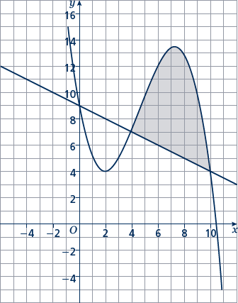
Example 2 Estimate the shaded area.
Use three strips of width 2 units.

x | 4 | 6 | 8 | 10
y | 7 | 12 | 13 | 4

x | 4 | 6 | 8 | 10
y | 7 | 6 | 5 | 4

Practice
Hint:
For a full answer, remember to include ‘units²’.
- Estimate the area of the region between the curve y = (5 − x)(x + 2) and the x-axis from x = 1 to x = 5.
Use four strips of width 1 unit.

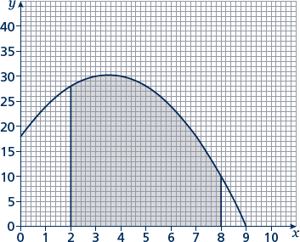
- Estimate the shaded area shown on the axes.
Use six strips of width 1 unit.

- Estimate the area of the region between the curve y = x² − 8x + 18 and the x-axis from x = 2 to x = 6.
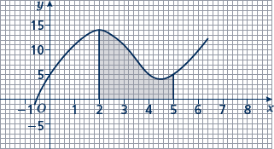
Use four strips of width 1 unit.

- Estimate the shaded area. Use six strips of width 1
2

unit.

- Estimate the area of the region between the curve y = −x² − 4x + 5 and the
x-axis from x = −5 to x = 1. Use six strips of width 1 unit.

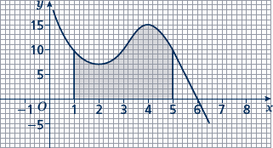
- Estimate the shaded area.
Use four strips of equal width.

- Estimate the area of the region between the curve y = −x² + 2x + 15 and the
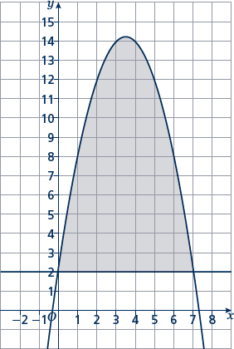
x-axis from x = 2 to x = 5. Use six strips of equal width.

- Estimate the shaded area.
Use seven strips of equal width.

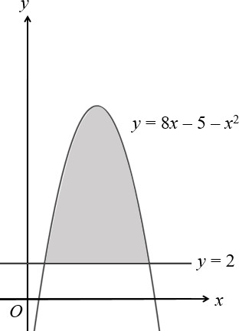
Extend

- The curve y = 8x − 5 − x² and the line y = 2 are shown in the sketch.
Estimate the shaded area using six strips of equal width.

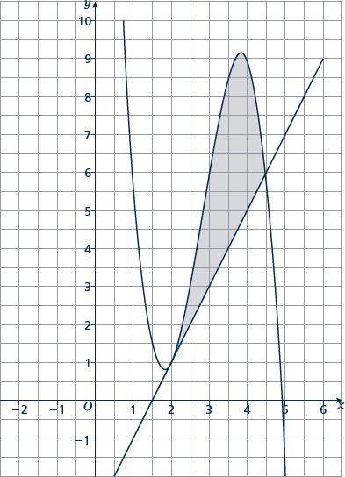
- Estimate the shaded area using five strips of equal width.

Answers
- 34 units²

- 149 units²

- 14 units²

- 25 1
4
units²

- 35 units²

- 42 units²

- 26 7
8
units²

- 56 units²

- 35 units²

- 6 1
4
units²

