26th June 2026

Dear Parent/Carer,

Re: Important Changes to Free School Meals & How to Apply

We are writing to let you know about important national changes to Free School Meal (FSM) eligibility starting in September 2026, and to explain why it is still vital that you apply using our quick online system.
What is changing?

Following new guidance from the Department for Education, FSM protections that have been in place since April 2018 will be ending in August 2026, and eligibility criteria is expanding. From September 2026, every child whose household receives Universal Credit is entitled to free school meals. We strongly encourage all of our families to complete an online application, if you have not previously done so, even if you don't believe you meet the criteria.
Please note: under the new national guidance, a child's eligibility will now be subject to an annual review to confirm their ongoing entitlement.
Why you should apply

- Healthy Meals: Your child can receive a nutritious lunch every day, helping them focus and learn.
- Extra School Funding: If you qualify, our school may receive extra funding (Pupil Premium) to pay for valuable learning resources, extra staff, and clubs—even if your child prefers packed lunches.
- Extra Benefits for Your Child: Registering can potentially qualify your family for additional support, such as help with the cost of school trips, uniform allowances, and free holiday activity clubs.
- Sixth Form Students: Additionally, under the new guidance, this expanded eligibility has been extended to include Sixth Form students, meaning older pupils who meet the criteria may now qualify for free school meals for the first time.

How to apply online

Please apply as soon as possible via our secure online portal:

https://apply.cloudforedu.org.uk/ofsm/sims-greenshawlearningtrust

The form only takes a few minutes to complete, and you will usually get an instant result. Once you have completed the form once, you will not need to reapply. Please note: If your family has No Recourse to Public Funds (NRPF), please contact the school office directly, and we will help you complete a confidential manual form.

If you need any help applying, or have any questions, please contact: admissions@henleybankhighschool.co.uk

Thank you for helping us secure the best possible funding and resources for your child.

Best wishes,
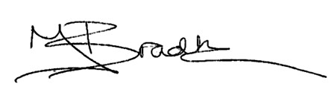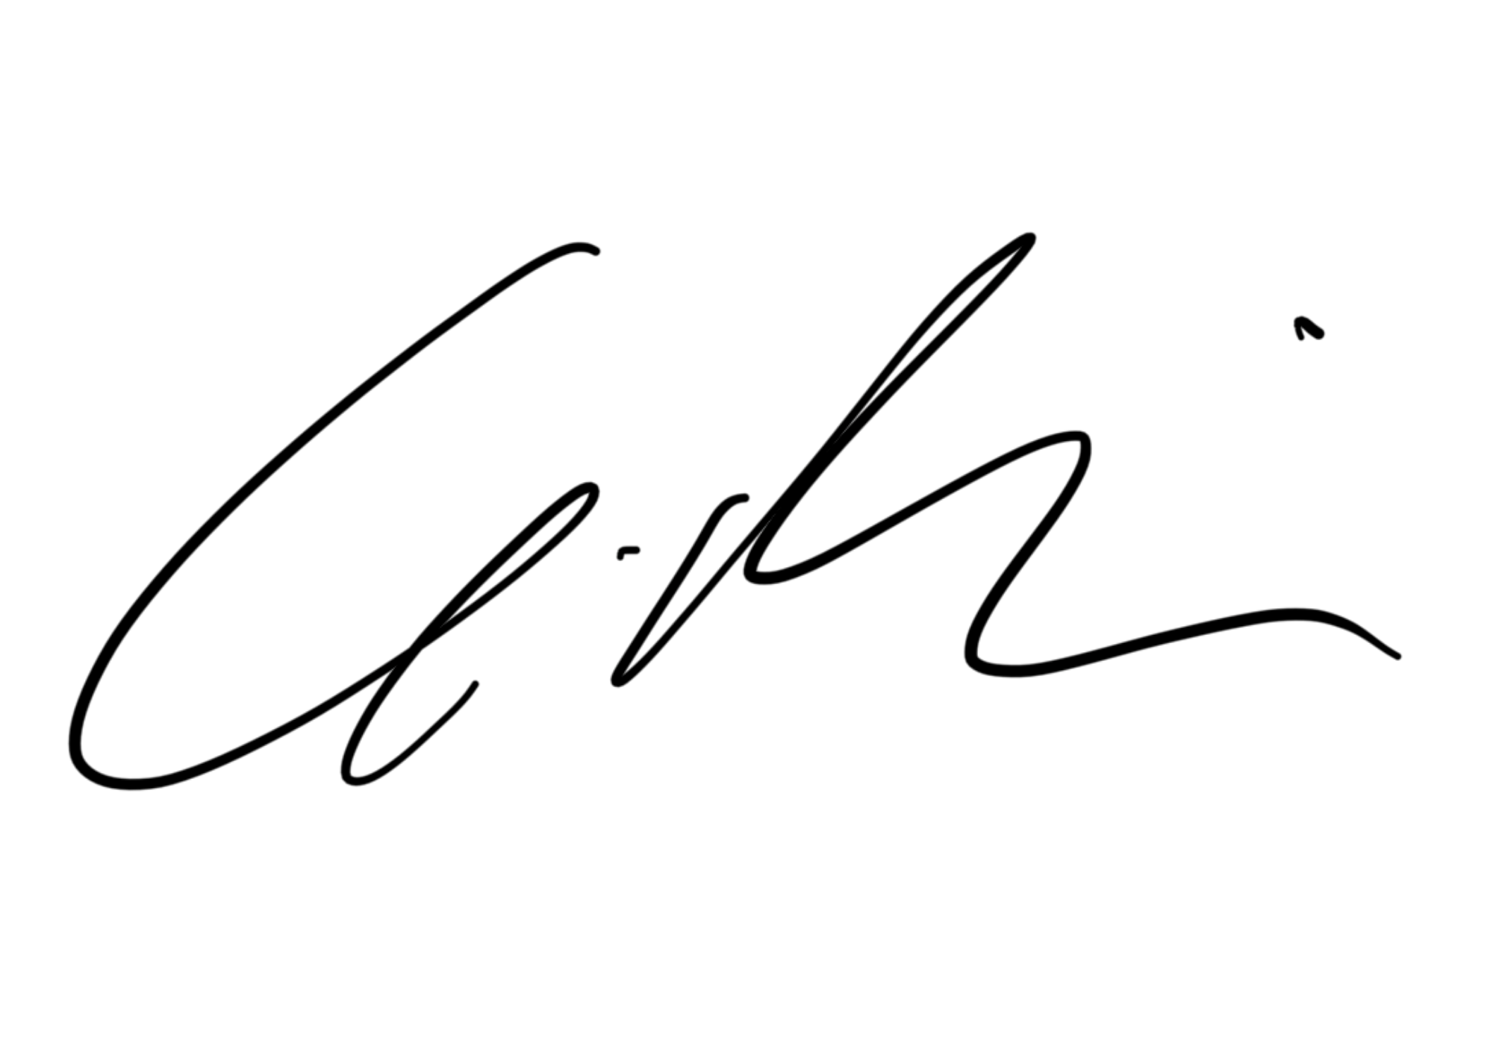

Ms Bradbury & Mr Dakin
Co-Heads of School



